ædlxnf k'?ifsf] ;+o"Qm k|of;, x'g ;S5 ;d'bfosf] ljsf;Æ
MCDC Annual Report 2080/2081 ( 2023/024)
dx'nL ;fd'bflos ljsf; s]Gb|,;Kt/L
Mahuli Community Development Center (MCDC) Saptari
30 Annual Progress Report 2023/024
#) cf}+ jflif{s k|ltj]bg @)*)÷)*!
- Back ground,
Mahuli Community is a purely non-profit making non-governmental social development organization, established in 1994 legally Registered under the act of 2034 in Saptari District Administration Office named Mahuli Yuwa club . After two years struggle then affiliated with Social Welfare Council (SWC) Affiliation No. 3260. This MCDC has crossed 30 years and running in 31 years for social development. It started its social development journey from education sector and stated child literacy and adult literacy in 13 VDC with 55 Classes. During this Journey, We feel there is other reason for low interest for education. The main reason was hunger and poverty. The basic needs of human life is safe house for rest, food for getting energy to live and clothes for cover the body, after then other others.
This was main learning from literacy classes when we monitored of the field. Necessity is a mother of invention. We begun to think for long solution of this reason. After then MCDC has started local level informal micro credit services from its generated fund from 1997 with literacy classes like integrated services. The main objective of this thought is reducing of poverty by generating self-employment system. It needs to develop skill, capitalization by regular saving and forming groups for unity. During this journey, MCDC was succeed to get intermediatory license from central bank of Nepal Rastriya bank and started formal micro finance services. After that MCDC became two parts, one is micro finance and other is social development support for raising up the poor, marginalized, backward community. MCDC had been launching with successfully both parts as parallelly and separated microfinance part into D class Bank under the company act 2063 in 2070 BS. Nowadays the microfinance is known as Mahuli Laghubitta Bittya sanstha ltd. It is national level D class bank and successfully running now under the Company act 2073 and MCDC has been working purely social development sector by getting support from different partners GOs and NGO/INGOs.
- Information of Organization:
Name of organization | Mahuli Community Development center (MCDC)
Type of organization | Local NGO
Full Address | Agnisair Krishna Sawaran RM-5, Bakadhuwa, saptari, Mahuli
Organization contact number | 031 -411004,
Organization email | info@mcdc.org.np/mcdc.silverjubilee@gmail.com
Website (if any) | www.mcdc.org.np
Chairperson’s name | Mr Shyamkant Chaudhary, 9842820176
Name and position of contact person | Mr Prabhu Narayan Chaudhary, Executive secretary & director
Contact number and Email of the contact person | 9842820100, 9801549905, pnchy35@gmail.com
Date of last Annual General Meeting held | 2080-7-20, 6 No 2023
No of executive board’s meeting in last Fiscal Year (2080/081) | (14 times In 080/081 )

- Registration, affiliation, and renewal information:
S.N. | Agency affiliated with | Date | Registration No | Last renewal date
1 | Registration in District Administration Office, Saptari, Rajbiraj | 2051/2/30 BS | 23 | 2080/6/23
2 | Social welfare council (SWC) | 2052/6/4 BS | 3260 | 2079/7/22 for 3 Years
3 | NGO fed
4 | Last Audit | 2080/6/03 |  | 2081/5/12
5 | Tax office VAT / PAN no |  | 301732622
6 | Tax discount Certificate | 079-2080 | 301732622 | 2080-6-27

- Vision, Mission, Goal and objectives of organization:
I.Vision: Formation of creative, inventive, empowers society through community development and social mobilization for establishment of self sustains Institution.
Ii.Mission:
- Uplift the Socio-economic status of marginalized poor people through working the participatory development program.
- Achieve the sustainable development through maximum mobilization of local available means, resources and skill.
- Increase gender equality and awareness for the rural community women's capacity building and approach to basic human right needs.
iii. Goal.
- To promote the sustainable organization to provide social services to the poor vulnerable people.
- To approach of 90% of targeted and vulnerable people in local marginalized and low resources community for human basic needs through social mobilization by capacity building for their rights to fulfill the basic needs.

- Objectives:
► Assist to meet of national goal for poverty reduction.
► Assist to meet SDGs goal of the Nation .
- Assist to empower of the poor , Marginalized backward, Disadvantage groups.
- Helps to develop Claymate resilient
- Helps to make healthy and neatly society.
V. Activities .
- To increase public awareness for various parts
- To create self-employment and income generating program.
- To uplift the socio-economic status of poor people through community based skill development training.
- To increase public participation for the sustainable development through social mobilization.
- To support for homeless and prone area home by using modern technology to make safe house using local resource to reduce disaster.
- To support for pure drinking water and wash system strengthening.
- To Promote the CBOS for self help by income generating to reduce unemployment .

- During 30 years, MCDC has accomplished more sustainable work for the community development by getting support from different donor organization and generated its core fund.
- MCDC has developed Micro Finance services and separated it as D class Bank. It is national level D class micro finance under the act 2063, Bank tatha Bittiya sanstha and registered under the Cmpany act 2063 as public company.
- MCDC has also done sustainable work successfully by promoting 6 cooperatives in saptari, These all are running successfully till now.
- MCDC has created more income generating opportunities for marginalized and poor families through agroforestry, vegetable farming, fisheries pound, Catchment pound for irrigation, river conservation by making dame and planting there. It gives more income to the related beneficiaries.
- MCDC has succeed to support to build new houses with toilets for more than 4710 Disaster affected, land less, disabled, vulnerable homeless , ultra poor families to support build resilient communities.
- MCDC has supported to three Dalit Communities for installation of sustainable pure drinking water scheme for 212 Families and direct 1113 beneficiaries.
- MCDC has promoted two Private sector for small industries of local material used for multi purpose.
- MCDC has been successful for land registration certificate for 116 landless families under the guideline and policy of land commission.
6. History of 30 years programming support and program and successfully operation.
1. MCDC had received funding support for informal literacy in 9 VDC with 45 Center from DEO Informal literacy board.
2. MCDC got an opportunity to collaborate with MCPW ( Micro Credit Program for Women) Funded by Asian Development Bank from 1998-2001. MCPW supported us in different sector for capacity building, Institution Development and linkage of Bank and Financial institution.
- MCDC became success to take license from central Bank for financial intermediately for 4 VDC in Saptari in 2000 AD. So MCDC formed more women groups in targeted Community.
- After then different donor agency believed to MCDC to support for Community development Like
(RCIW, world Food Program, FFW, IFSP,RPN - GTZ,). from 2000 to 2008.
- Humanitarian Support program for Koshi flooded victims supported by Concern Nepal and Funded by WFP.

- Pact Ekta Nepal, DED Program with Germani Project, DLGSP program with Ministry of local Government Development, US AID program for youth mobilization, NGO/ CBOs from 2001-2009.
- CGISP program for irrigation for farmers supported by Irrigation Department,Lahan in 2001. But it was not success.
- For Kuipcy and, EAFS program , support from UNDP/UNCDF. 2008 and 2010-2012
From 2009, Poverty Elevation fund has been supporting to MCDC still now for 1500 poor house holds in 7 VDC.
- Local Governance Community Development Program was launched again supported from DDC from 2009-2012
- Enhance Access financial Support Program was launched from 2009-2011 supported by NRB and funded by UNDP and UNCDF for Institutional Capacity Building to serve the large numbers of target groups.
- After then MCDC became success to Partnership with Habitat For Humanity Nepal from 2009 and continue in collaboration for housing support for Micro finance clients.
- Fund Board has supported for drinking water and Sanitation from 2011to 2015.
- MCDC has completely succeed Program for Responsibility Activities Nepal (PRAN -1 and 2) partnership CECI and funded by WB in 2012 to 2016.
- MCDC has developed D Class Bank for its microfinance and separate it to D Class Bank, Named Mahuli Sammudayik Laghu Bitta Bittya Sanstha Ltd in 2013.
- MCDC has succeed to Declare ODF in 2 Municipality and 2 VDC in Saptari by getting support from UNICEF according to National Sanitation Master Plan.
- MCDC has worked with collaboration of Helvetas and ICIMOD to make water use master Plan of 4 VDC in of this district in 2015-2016.
- Community management with housing and land management for land less and homeless family by collaboration of Local Government and getting funding support for different 19 projects from Habitat Nepal since 2016 to till now.
- MCDC has got opportunity to construct of public toilet partnership with SNV Nepal in 2020.
- MCDC has also gotten little support from wine to water Nepal for covid 19 Response in 2020
- Strengthening municipal wide wash governance for social change in saptary, Partnership with WHH and funding support from BMZ/VCA. From 2019 to 2022.
- Up – Scaling Wash systems Strengthening Approach in the Terai Region of Nepal (NPL 1082-22), Partnership with WHH and funding support from BMZ/VCA. From 1 March 2023 to End Feb 2026.
- From 1 July 2023, Again signed with new project partnership with Habitat Nepal for homeless family, Disaster affected Palika and Market System Development and support vulnerable community for building resilient communities support to build low cost house.
- From 16 July 2023, Collaborating support agreement for technical and facilitation support with Local Government office Agnisair krishna sawaran RM for the land right advocacy under the guideline Rastriya land commission of Nepal.
- . Up to till, partner & collaboration ship donor organization support to MCDC for community development .
7.A Government organization
1. Local government (VDC, DDC, RM, Mun) Time to time matching support.
2. District Education Office for two project. 3. MCPW -MLD (ADB) for 2 project
4. NRB. for microcredit 5. Regional Irrigation Office, for 1 project
6. DLGSP, LGCDP, (ADB) 7. PAF, (NG, ADB)
8. DWSDO. For two project 9. Fund Board for 1 Project
10. Local Government for Land right advocacy and facilitation of the land less people for land Regd Certificate of Agnisair Krishna Sawaran Rural Municipality.

7.B Non-government Organization
1. GTZ for 5 project 2. Pact Nepal for 1 project
3.Concern Nepal. for 1 project 4. USAID for two project
5. DED. For IG support. 6. Quipsy. (UNDP)
7.UNDP/UNCDP for 1 project 8. CECI for PRAN -1, 2 for two project
9. UNICEF, for two project 10. Helvetas / ICIMOD for 1 project
11. Joy foundation for 1 Project 12. PA Nepal for 1 Project
13. SNV Nepal. for 1 project 14. Wine to Water Nepal. For 1 Project.
15. Habitat for Humanity International Nepal for Different 23 Project and till now hosing and disaster management and land right.

16. With Partnership of VCA/BMZ/ WHH for two Projects. One is NPL -1060- 18 which is accomplished in Feb 2023 and other is running now NPL 1082 from 1 March 2023 to Feb 2026.

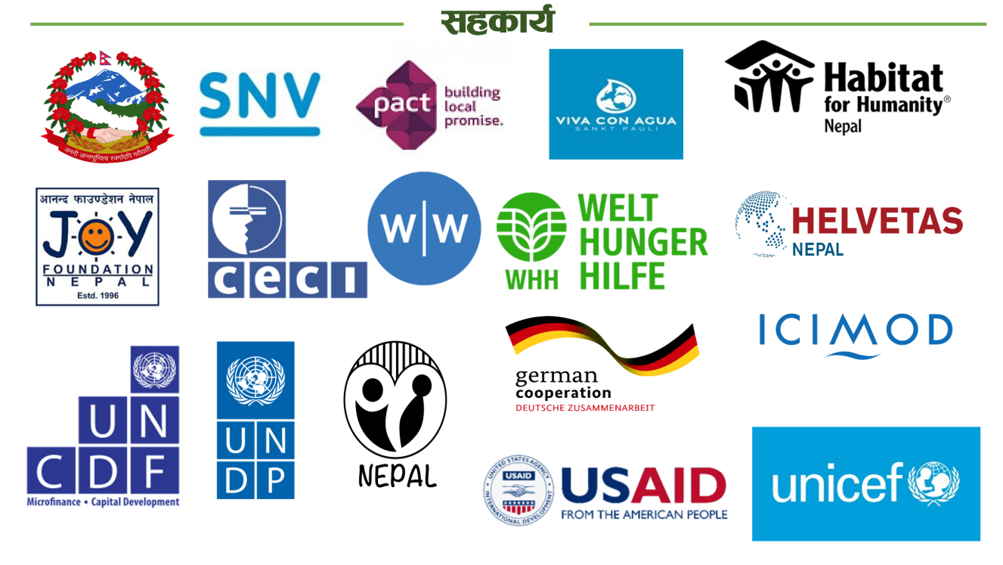

8.

9. Partnership 2080/081
Shambhunath Mun
Habitat Nepal
Shambhunath Mun

AKS RM
Dakneshowry Mun
Dakneshwory Mun
Partner Organization
Local Government
MCDC
Local Government

Rajgadh RM
Saptkoshi Municipality.
WHH/BMZ/VCA
Bishnupur RM

Detail of Financial resources for Community Development.
Bishnupur RM
Rajgadh RM
SN | Project | Supporting Donor | This Year | Last year | Remarks
1 | In Wash Governance Project.  Upscaling Wash system | WHH/BMZ/VCA NPL 1060 |  | 14718208.69
1 | In Wash Governance Project.  Upscaling Wash system | WHH/BMZ/VCA NPL 1082 |  | 4563925.50
1 | In Wash Governance Project.  Upscaling Wash system | Total from WHH partnership for Wash |  | 19282134.19
1 | In Wash Governance Project.  Upscaling Wash system | Local Government & contribution |  | 700000.00 | Direct community
1 | In Wash Governance Project.  Upscaling Wash system | Total resources |  | 19982134.19
2 | In Safe Housing construction, DR3, Land right, Digo Samuday. | Habitat Nepal |  | 18171618.57
2 | In Safe Housing construction, DR3, Land right, Digo Samuday. | Local government and local contribution |  | 90,00000.00 | Direct community
 |  |  |  | 27171618.57
3 | Land right advocacy for land certificate | Local Government / AKS |  | 6,00000.00
 | Total | Total Resources |  | 47753752.76
4 | Internal | Organization MCDC |  | 1382217.22
 | Total use of fund for community development. | Total budget used for community Development through mobilized by MCDC |  | 49135969.98
10. Financial resourese of MCDC , cumulative
External Support
Internal Resources

PROJECT OPERATION DONATION
Total Income as Donation for project operation from all partners = Rs 240839173.16

Member fee, Bank Interest,
Bamboo treatment services Fees,
Ambulance Services and share dividend.
Total this = 27,17,64,496.85

Total transaction of up to Fy this year NPRs
= 51,26,03,670.01
10. Annual General Assembly :
Our organization constitution’s rules no. 14. General Assembly is the highest body of the organization. General Assembly should be organized within six month of the fiscal year. All program's progress Report and annual plan approved by AGM. Executive body of the board (Board of directors)  elected or selected by General assembly as democracy mandatory. Various Needed directives and guideline Approved by the AGM .  AGM gives direction to the board for organization Operation and community development. There are also provision of board meeting in the MCDC constitution at least 12 times in year. It completely comply.  In this reporting year, the AGM had organized BS 2080/7/20 on (6 NO 2023) and successfully completed in the chairing of Shyam kant Chaudhary, Chair person of MCDC in the presence as chief guest province members honorable Raj kumar lekhi . MCDC as pure social development organization is known in the Saptari , but not know about it deeply, I’m so proud of MCDC and appreciate for the social development work by his speech.  The progress Report and Financial status of MCDC are presented by Executive secretary Mr Prabhu Narayan Chaudhary, welcomed by General secretary Mr Shrawan Kumar Chaudhary and operated by Assistant Director Mr Chandra Narayan Chaudhary. | 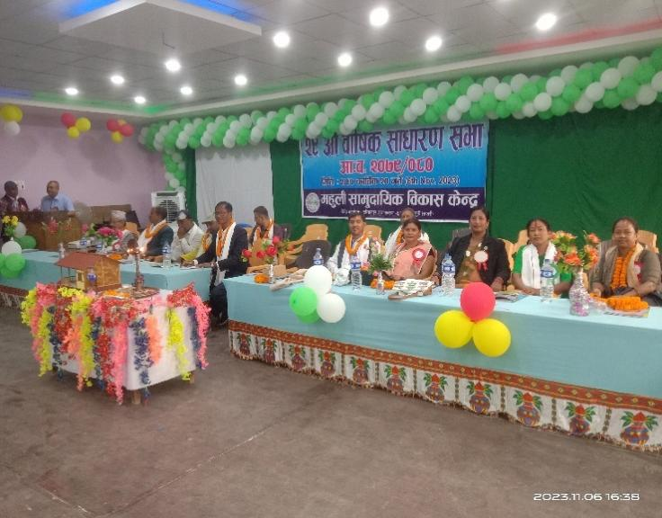  Inauguration 29AGM Of MCDC by Chief Guest Honorable Raj kumar Lekhi Member of Province Madhesh .  Annual Report is being presented by Executive Secretary Mr PN Chaudhary.

(i) Present board of directors
SN | Post | Name | Gen | Membership | Remarks
1 | Chair person | Mr Shyam kant Chaudhary | M | Fonder members of the organization
2 | Vice chairperson | Mrs Asha Kumary Chaudhary | F | Life Member
3 | Maha Secretary | Mr Shrawan kumar Chaudhary | M | Active Member
4 | Executive Secretary | Mr Prabhu Narayan | M | Fonder members of the organization
5 | Member | Mr Akshmitlal Chaudhary | M | Life Member
6 | Member | Mr Durganad Chaudhary | M | Active Member
7 | Member | Mrs Meena Kumary Chaudhary | F | Active Member

(ii) New Advisors of MCDC
SN | Post | Name | Gen | Membership | Remarks
1 | Advisor | Mr Ram Lagan Mandar | M | Life Member | Previous Chairman
2 | Advisor | Mo Aziz Khalipha | M | Fonder members of the organization | Previous vice Chairman
3 | Advisor | Mr Bijali Prasad Chaudhary | M | Active Member | Continue

11. Meeting of Board of directors in reporting year 2080-081 BS.
Board committee is the most responsible body for smoothly run by taking right decision for the organization. The board is responsible for good governance of the organization and all management system and operation. It should coordinate with different donor Partner and line agency of getting support for the community development for the marginalized Community. The activities are monitored by board and review of activities. The board takes valuable decision in various issues which comes time to time. This committee is successful to run its operation by 14 meeting in current reporting year . The needed guide line and policies formulated under the government act and community need. This committee is the most responsible body for the Annual General Assembly and organization management system .
12. Annual Aniversary celebration .

MCDC has been celebrating of annual anniversary since its established day in each year through different activities . In this reporting Year , MCDC has been organized annual celebrated its annual day jointly with Mahuli Laghubitta Bittiya Sanstha by plantation activities to preserve the enviroment . More than 10 thousand plants has been planted in the variouse communities , in the school, religious place, barren place in the forest in the chairing of Chair person Mr Shyam kant Chaudhary . The Participants were from different stakeholders , Board members, Staffs , Beneficiries, local leaders. | 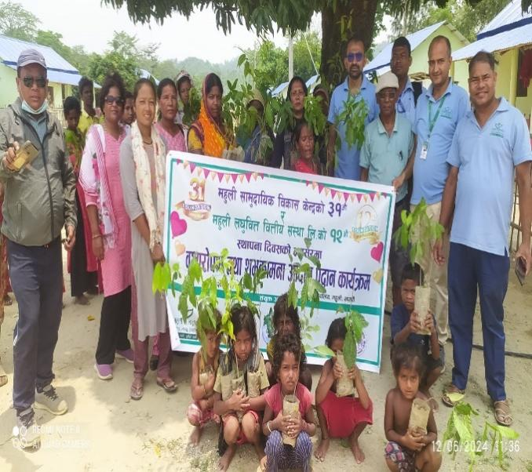

14 . Land right Advocacy and faciliatation for landless faimilies .
MCDC started mission of advocacy for lad right for landless people what is citizen right under the land management act of 2021 and land commission guideline 2078. Various types of campaigning started by MCDC to aware of targeted families and communities who are living without authorised land and no right on living land.
MCDC had started campaigning for land right advocacy in the targeted community.
Capacity building to Ward level facilitation Committee.
organize Interaction meeting with different political parties representatives.
organize Interaction meeting with Palika level representatives.
Organize meeting with land survey surveyor.
Organize district level learning sharing workshop for land right issues and challenges.
Organize monitoring and field visit by District level land commission team.
Achievement.
It created the environment for land receiving as process of land guideline for landless.
Completed of Data collection of lan dless families of Agnisair Krishna Sawaran RM. Total House are 856 of landless families.
111 landless families have succeed to received land Certificate from land commission Office.
78 landless families are in door for receiving Land certificate.
at present, Land survey work is being continue of remaining houses holds.

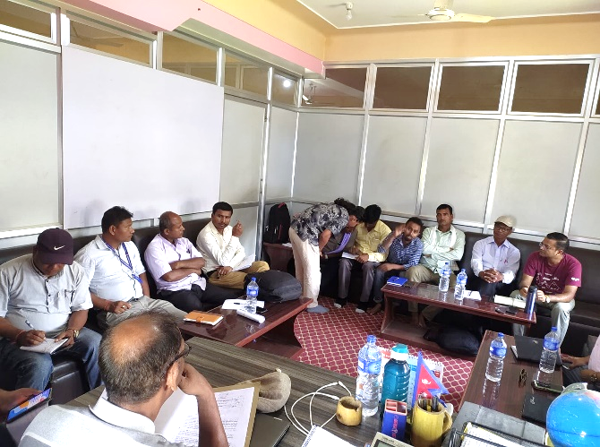
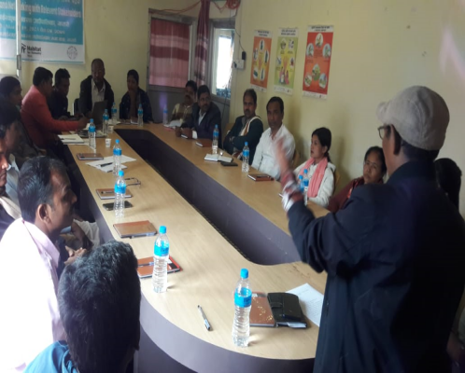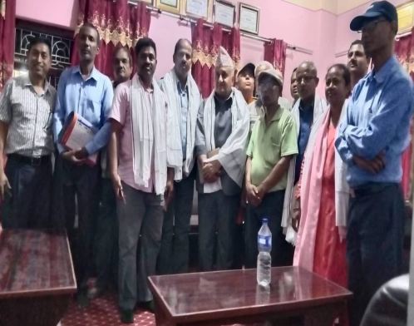
Joint Planning meeting for land right.
Land Advocacy with National and Distrct level Land commission
Land Advocacy with Local gov Level

15 . Present Partnership with Development Partners
Habitat Nepal (HFH) | Welt Hungerhilfe(WHH)
Partnership from 2009 and continue till now | Partnership from 12- 12 -2019 and continue till now
Name Of Project :  Surakchhit Awash for houseless people. | Name Of Project :  Up-scaling WASH systems strengthening approach in the Terai region of Nepal.
Sector : Safe housing construction,  Pre Disaster Managment,  Market System Development ,  Land right advocacy. | Sector : (i)Awarness and capacity Buildng for disadvantage community for sustatainable hygeine is improved and build up capacity of WSUGs .  ii. CLTS and campaigning .  iii. Wash System Strengthening of municipal to deliver climate resilient, safe, sustainable, and accountable WASH services.  V. Support for School Wash and Health care facility.  vi. Sustainable Drinking water .  vii Technical Assistance support for municipal Wah planning and implenting .
Working Municipalities.  Agnisair krishna sawaran RM , Saptkoshi M and Shmabhunath Mun .  Project Duration . 1 Year . from 1 July 2023 to 30 June 2024. | Working Municipalities. :  Dakneshwori, Bishnupur, Rajgadh, Saptakoshi and Agnisair in Saptari district (40 wards), Madhesh province,Nepal.  Project Duration : NPL 1082  36 months, from March 2023 to FEB 2026
Funding Donors : Hilti Foundation, Tithe,  Inse- Kaindal , Defeaid , Habitat International, | Funding Donors : Viva Con Aguwa (VCA), Zerman, (BMZ) WHH.
Detail Report in the Project Base report | Detail Report in the Project Base report

Project Completion Report
1st July 2023 – 30th June 2024

16.

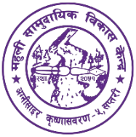

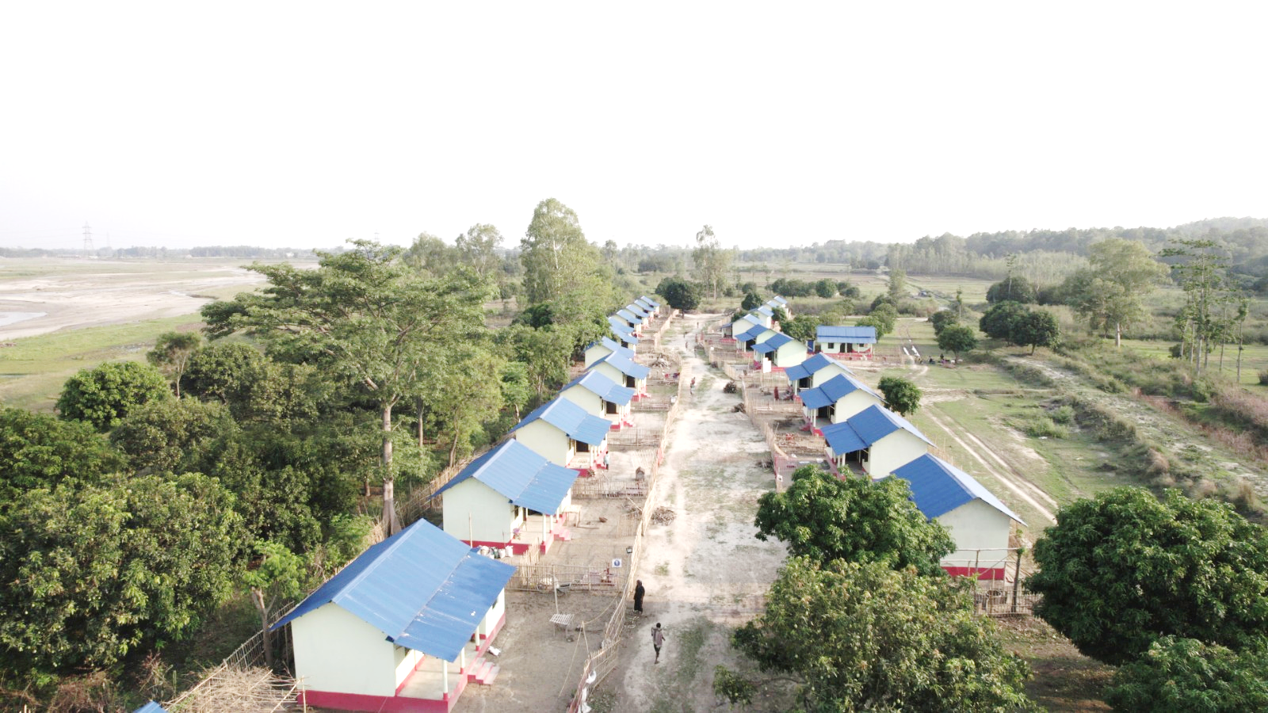
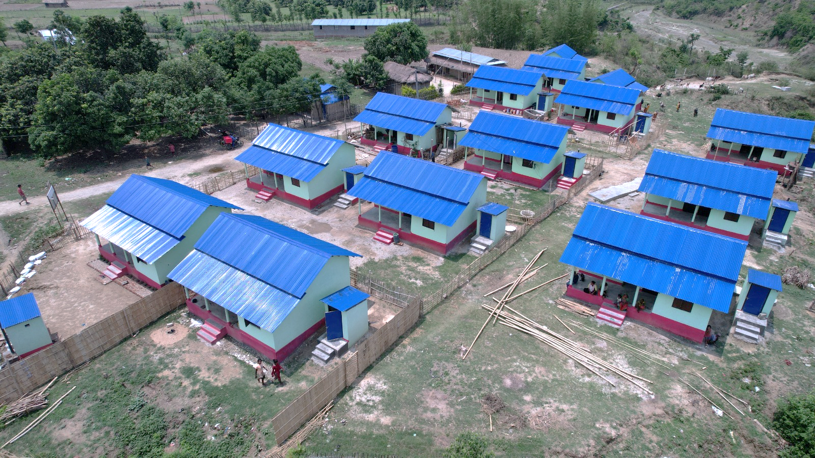
Surakshit Aawas Karyakram
  - EXECUTIVE SUMMARY:
Habitat for Humanity Nepal and Mahuli Community Development Center work together since 2009 for helping people in Saptari district Nepal continuously. Empowering people specially core poor, land-less, homeless, Dalit, Marginalised community, in the process of providing low cost and sustainable safe housing, using local materials, are at fore front of the partnership with various Projects. Partnership with Habitat Nepal .MCDC has successfully completed 26 projects, In the support of Habitat Nepal for three Palikas in Saptari. This Surakshit Awas Project started from 1 January 2022 and running continuously till June 2024.
16.2 Donors for Funding Support :
There are four donors for funding support for Surakshit Awas Project .
- Hilti Foundation support for promoting Bamboo is using in multiple sector for Human life and Market System Development .
- Inse-kaindal support for Land right and cost effective safe housing for helpless land less.
- Tithe : support for Disaster management .
- DEFAT support for Resilient of disadvantage Families.
This reporting year with the "Hilti Housing project" the "Santa Barbara project", the "RISEN project " and the "Paving the way for equal housing and land rights Project". The project has been success to support home to most vulnerable people, core poor, and disable, single female households with safe and secure houses using treated bamboo through CEMENT BAMBOO FRAME TECHNOLOGY (CBFT).
16.3 Basic Information
Project Duration | 1 July 2023 to June 2024
Project Location & Collaboration | - Agnisair Krishana Savran Rural Municipality  - Shambhunath Municipality and  - Saptkoshi Municipality
Partner Organization | Habitat for Humanity International Nepal
Funding Organization | - Hilti Foundation,  - DFAT  - Australian Aid, DFAT ANCP  - INES KAINDL
Reporting period | 1 July 2023 to June 2024
Funding Budget Agreement | NPR. 20,756,924.00
New House Construction support  (Total 75 houses) | Hilti Model- 36 complete , 18- under construction .  Inse Kaindal support for 41 houses .
Targeted beneficiaries and new houses for 81 Families. | 41 houses supported from Inse kaindal and 40 House from Hilti foundation for dalit and homeless and landless families in the sapatari.
Real expenditure of this year | NPR = 1,99,11,409.22

  - Project Results:
Objectives | To provide shelter support to targeted families (ultra-poor, vulnerable, marginalized, and land less families and disable) who are unable to build safer houses on their own with their minimal earning.
Out come 1 | Treated bamboo is trusted as a building material in the Project area and influencing the people for bamboo housing solution.
Output 1.1 | Production of treated bamboo poles, purlins, rafter, joints and other section of accredited quality is able to keep apace with the demand of the construction sector. Two treatment centres operate on a sustainable basis.
Out come 2 | Finance providers (government) integrate bamboo-based housing into their portfolios and annual budget and program.
Output 2.1 | Government-subsidized housing projects in the local government prioritize bamboo housing designs, resulting in new houses annually as 104 government subsidized bamboo houses constructed through NPR 22,620,000.00 government fund leveraged for bamboo housing solutions. A market-based approach is utilized to promote bamboo house solutions in the project areas resulting in housing solutions annually.
Output 2.2 | - Five Hundred and twenty people of 104 families get A Safe, Durable and Affordable houses to live in.  - Thirteen Disable people have get easy access to the house and toilet.  One Hundred and Fifteen people of 23 families get a safer bathroom facilities and easy access to water through hand pump in their own premisses.

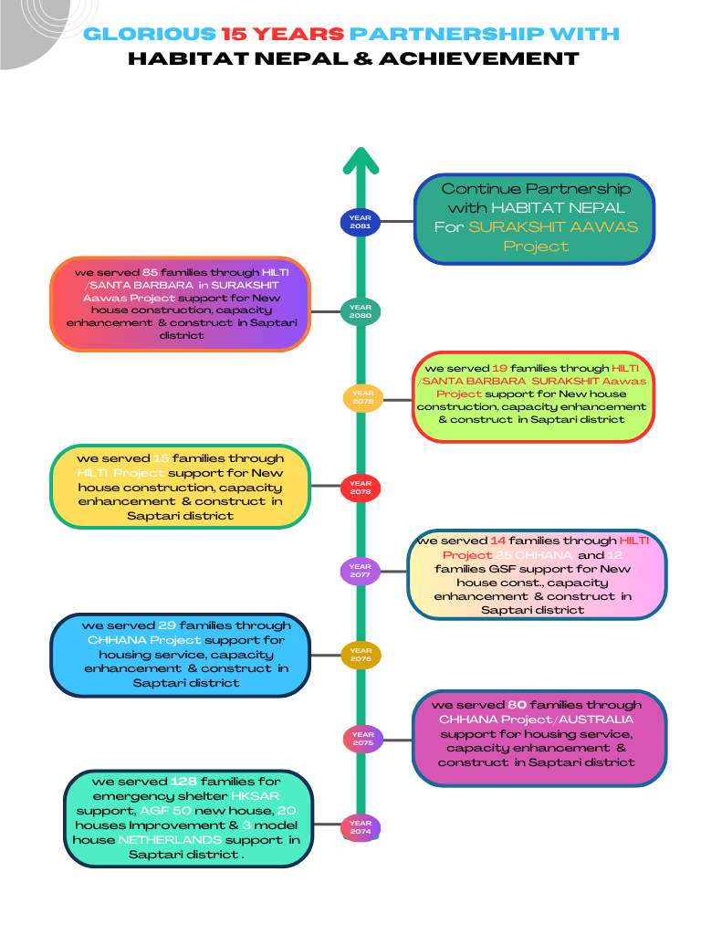
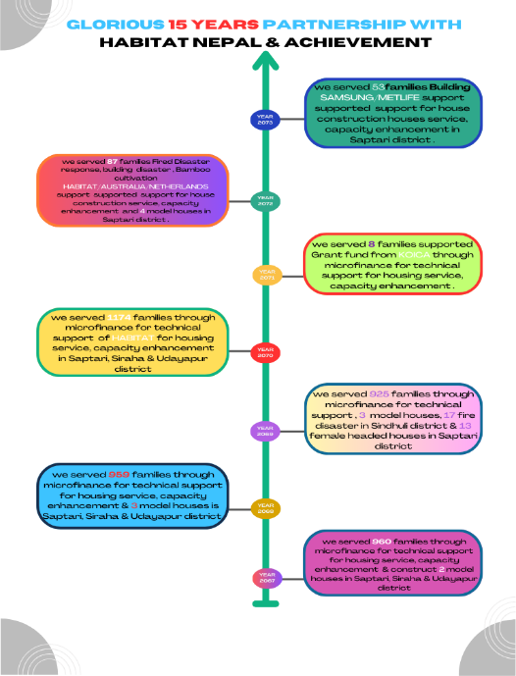

- PROJECT INFOGRAPHIC:
RESILIENT INCLUSIVE SUSTAINABLE EASTERN NEPAL(RISEN) Project at Shambhunath Municipality;
This mean "Resilient Inclusive Sustainable Eastern Nepal". For this project funding support from Habitat Australia. This project has been focusing on Disaster management of the community and enhancement of Disaster management plan of the local level Government. Under this project, awareness of the community people, Capacity build to be safe when natural disaster comes. To support to update Disaster Preparedness and Response Plan (DPRP) and Local Disaster and Climate Resilience Plan (LDCRP).
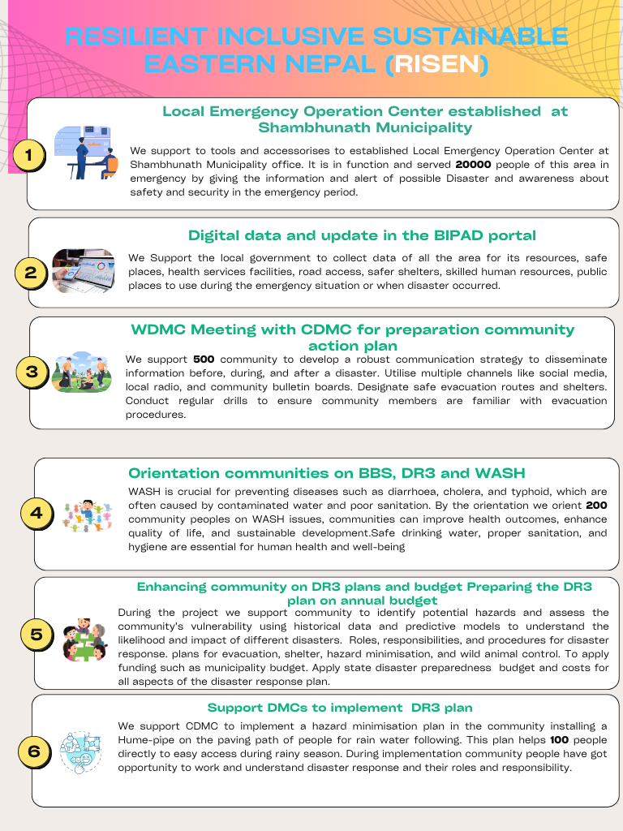
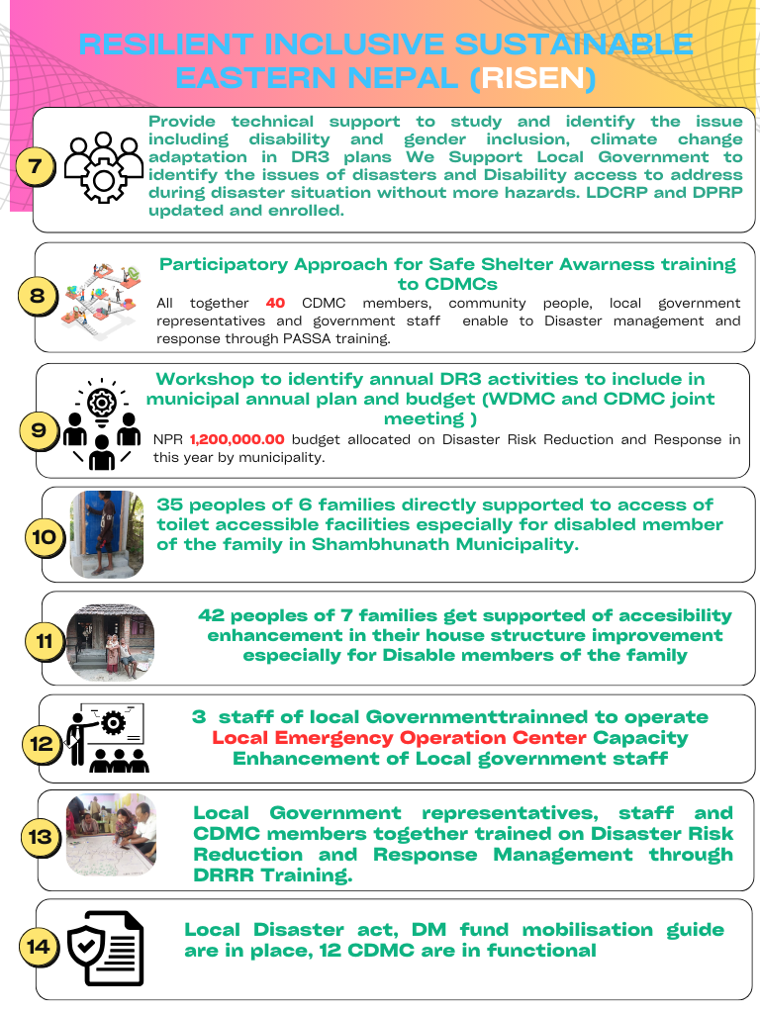
Market System Development to enhance local entrepreneur and creating self-employments. Under this project promoting local material for housing especially Bamboos. MCDC has succeed to promote two private sectoral bamboos treatment centre as small industries. One is in Saptari and another is in Siraha district. MCDC has supported them to as seed capital to installation bamboo treatment centre and develop local market. Lot of Bamboos farmers who cultivate bamboos have no earn income from bamboos. Due to this project small support gave high result for income generating sector. MCDC has organized workshop on local material targeted bamboo related stakeholders, Business man, meson, farmers. MCDC has organized capacity building training such as, business Management training, business plan training, value and chain. MCDC has organized interaction meeting to promote the bamboo Farming, its importance, using and cultivation knowledge.
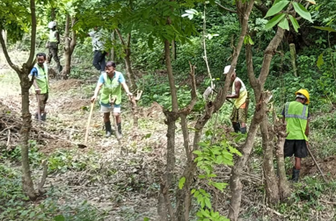
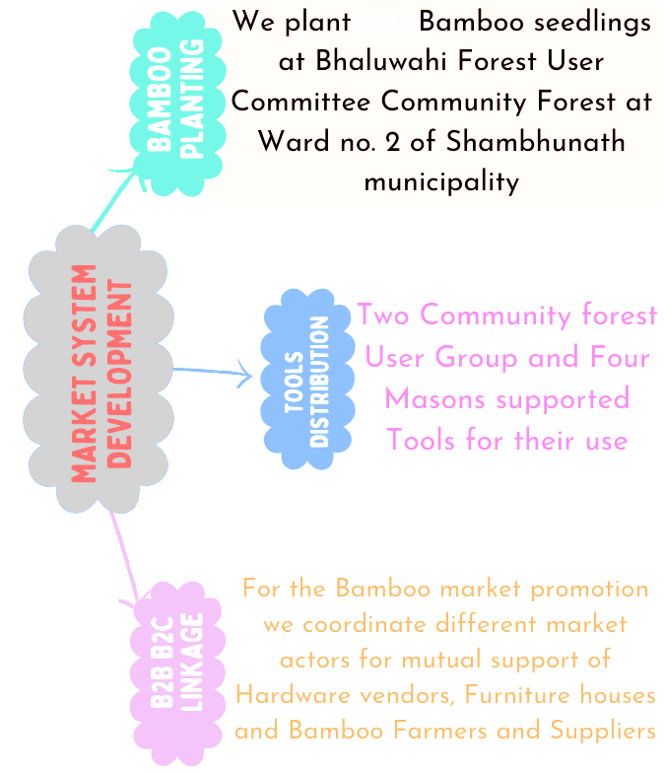
Two private sector promoted by this project, One is saptari, named Mahuli Bamboo promotion centre and another is in Sirara named Atmnirvar Agriculture firm.
- Mahuli Bamboo promotion Centre is formatted and self sustained private business firm and able to supply for than 50 lakh transaction in year.
- Capable to generate more than 8 local labour employment.
- It created to opportunities for local bamboos farmers to earn income.
- It helps the to supply treated bamboos to make low cost house construction.
- It helps for getting availability of treated bamboo to the housing project as per demand

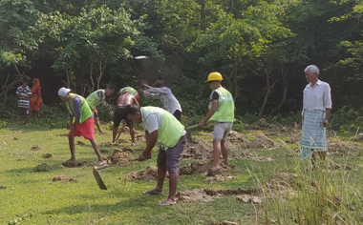

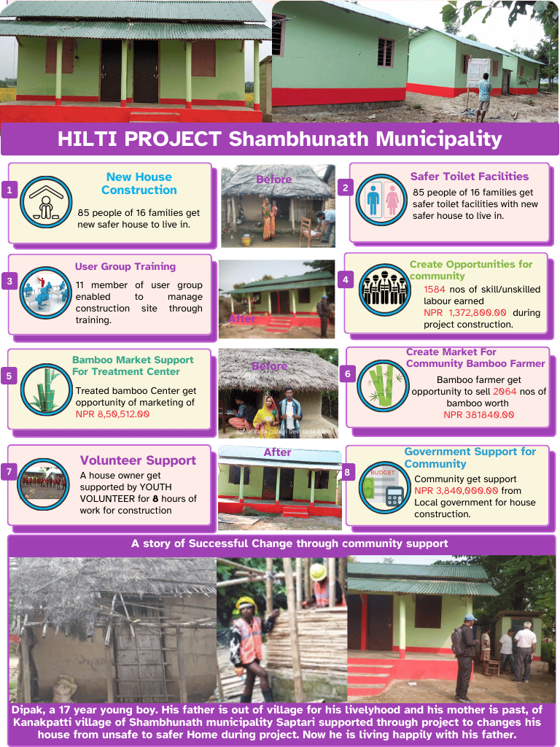
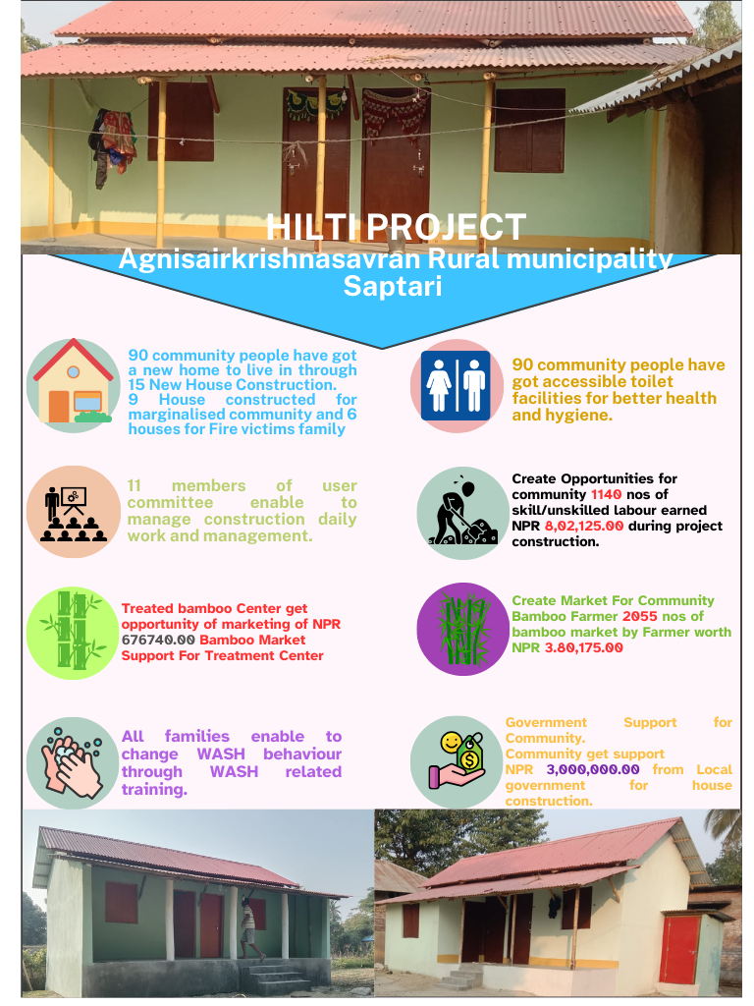
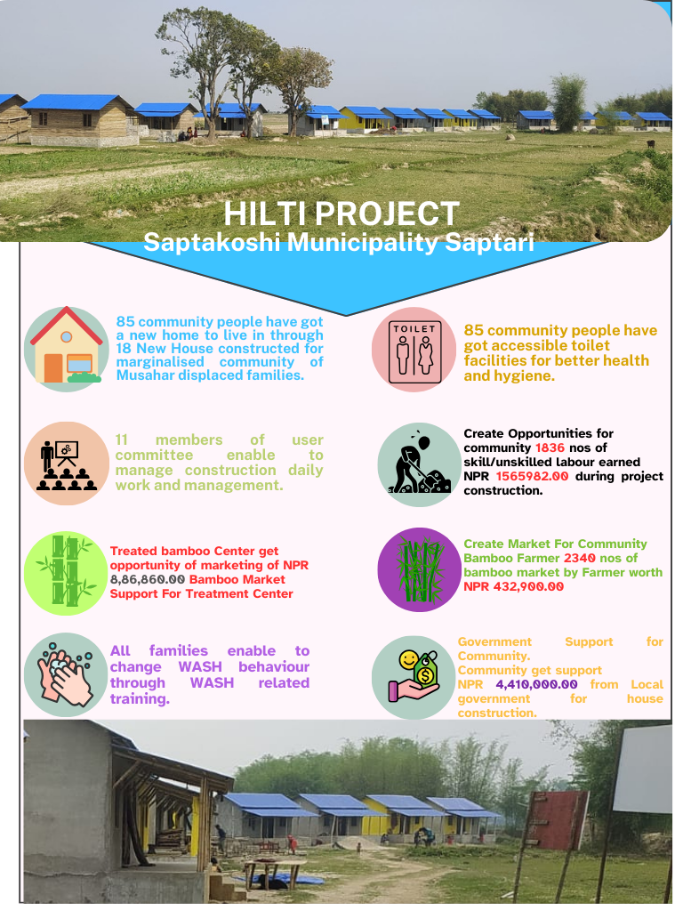
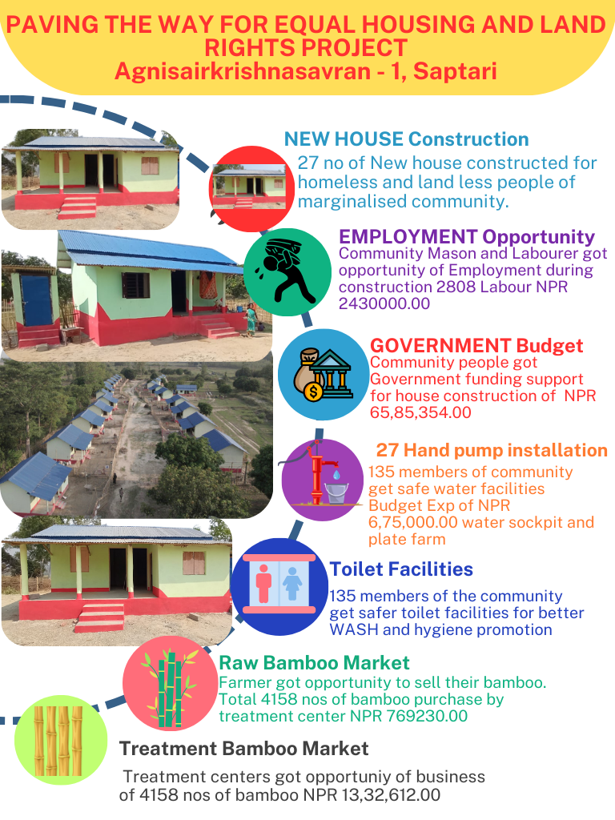
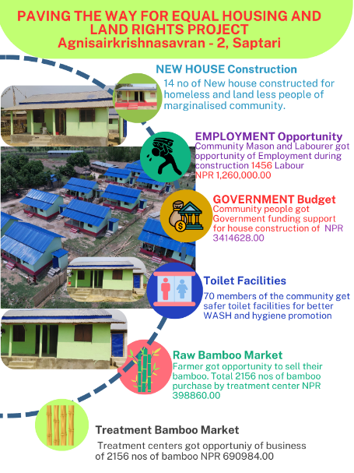

- Learning & Sharing:
- Successful continuation of construction work for 41 houses under paving the way for equal housing and land rights in a timeframe when respective local government active.
- LDCRP, DPRP and Disaster fund mobilization guide is approved and functional in Shambhunath municipality.
- DR3 plans and program is submitted in annual plan and program of Shambhunath municipality for FY 2080/81.
- Municipality allocated budget to all the ward committee for WDMC and CDMC.
- Coordinate with a forest user group for bamboo plantation support.
- Two Private Treatment centers registered, MCDC privatized its own TC in Saptari and new TC established Siraha and operating as a business entity.
VI. Issues and Challenges:
1. Person with disability whom we support under RISEN scattered from one to another places even in one village or street so transportation cost, labor cost, staff movement cost is very high in this case.
.2. Person with disability support toilet as incremental but most of them need to support drinking water too.
.3. Community mobilization and contribution is very difficult in the existing families whom we support under Uthansil Aawas due to their seeker attitude, so community contribution must keep under 5 precent to complete project in time.
- . It is the most difficult to manage of land through process and completion the house in short term Project agreement .
VII. Recommendation:
The Safe Shelter program has established strong partnerships with Local government, Habitat Nepal and stakeholders to ensure the effectiveness and success of completion. The program partnership plays a vital role in providing comprehensive aimed at improving the safety and well-being of most vulnerable people who don’t have a safe shelter. The program collaborates closely with local groups, beneficiaries, local government to address the specific needs and challenges faced by us and beneficiaries. Overall, this program partnership enhance capacity to meet the diverse needs and well-being, and successful transition to sustainable community.
- Prepared before project activity starts by plan, design, estimate, work activities and schedule of project implementation jointly both funding and implementing organisation.
- We focused on quality within quantity, community desire and local knowledge and skill to use more within the allocated standard of construction.
- RISEN project must extend all ward of municipality to take ownership of municipal board, to make board decision easy and timely for project implementation and budget allocation.
- Community need sustainable support of safe drinking water in place of water supply only of hand pump because water level is being very low in the terai region as effect of climate change and global warming problem.
- Incremental work like support to bathroom facilities and other small support is much better through Cash based support.
- Hand pump support is not resulting sufficient support in the long run due to water level in the terai region is very low and ironised water mostly.
16.5 Commulative housing support from 2009 to this reporting Date.
The Partnership with Habitat Nepal for focusing in Housing for homeless families are being 16 Years continuously. During the period, MCDC has accomplished the various project from different donor support partnership with Habitat Nepal. Summary Progress Report for Housing are given below.
Year | Housing Model | Support type | No. of houses | Location
2067/068 | Microfinance funding model | Technical support, enhancement and capacity building | 960 | Saptari, Siraha, Udaypur,
2067/068 | Model House | some materials and and technic from Habitat | 2 | Mahuli 1, Saptari Thelia 1
2068/069 | Microfinance funding model | Technical support, enhancement and capacity building | 959 | Saptari, Siraha, Udaypur,
2068/069 | Model House | some materials and and technic from Habitat | 3 | Rajbiraj, 1, Birendra Bazaar 1 sapari. Terhauta
2069/070 | Microfinance funding model | Technical support, enhancement and capacity building | 925 | Saptari, Siraha, Udaypur,
2069/070 | Model House | Maximum Support from Habitat | 3 | Theliya 3,
2069/070 | Fired Disaster support | Technical and partial, | 17 | Sindhuli
2069/070 | Female Headed project | Housing support, funding support from KOICA | 13 | Theliay
2070/071 | Microfinance funding model | Technical support, enhancement and capacity building | 1174 | Saptari, Siraha, Udaypur,
2071/072 | Grant funded support, | KOICA | 8
2072/073 | Responsible Disaster Sustainable Project | Habitat | 42 | Fired Disaster support in Saptari,
2072/073 | Building Disaster Resilient | Australia | 45 | Saptari
2072/073 | Bamboo Cultivation | Netherland | 4 | Model House,
2073/074 | SAMSUNG | SAMSUNG | 25 | Theliya. Dharmpur
2073/074 | Metlife / Supporting | Metlife Foundation | 28 | Bakadhuwa, -3 Theliya Gorpar
2074/075 | Bamboo Cultivation | Netherland | 3 model and 20 Improvement | Praswani, AKS 4 and 2, Itharwa
2074/075 | Emergency Shelter for flooding affected areas in Sapatri due to Heavy Rain. | HK SAR | 128 | Saptkoshi, Kanchanrup, AKS and Shambhunath
2074/075 | AG Fund New construction | Arabian Gulf Fund | 50 | AKS – 4 integrated housing.
2075/076 | CHHANNA, New Construction | Australia | 70 | AKS, 1-6
2075/076 | CHHANNA, New Construction | Australia | 10 | Shambhunath-2
2076/077 | CHHANNA, New Cons | Australia | 29 | Shambhunath-2
2077/078 | Hilti, New Cons | Hilti Foundation | 14 | Shambhunath-2
2077/078 | CHHANNA, New Cons | Australia | 25 | Shambhunath-7
2077/078 | GSF, New Cons | Global, Support Fund | 12 | AKS. 1
2078/079 | Hilti, New Cons | Hilti Foundation | 15 | AKS. 4
2079/080 | New Cons | South Santa Barbara | 14 | Shambhunath-2
2079/080 | Hilti, New Cons | Hilti Foundation new cons | 5 | Shambhunath-2
2080/081 | Hilti, New Cons | Hilti Foundation , new cons | 11 | Shambhunath-2
2080/081 | Hilti, New Cons | Hilti Foundation new cons | 18 | Saptkoshi-4
2080/081 | Paving the way equal | Inse kaindale New cons , | 41 | Agnisair Krishna Sawaran -2,and 4.
 |  | Total | 4678

17. Background of the Project
Detail Annual Report of Up scaling Wash System Strengthening approach in the Terai region Of Nepal ( NPL -1082-22)
PROJECT OFFICE-RAJBIRAJ
Mahuli Community Development Center (MCDC) has been implementing “Up-scaling WASH systems strengthening approach in the Terai region of Nepal (NPL 1082-22)” project in Agnisair Krishana Sawaran RM, Bishnupur RM, Rajgadh RM, Dakneshwori Municipality and Saptakoshi Municipality of Saptari district with the support from BMZ/VCA/WHH. It is the continuity with phase 1 project namely "Strengthening Municipal Wide WASH Governance for Social Change in Saptari District (NPL 1060-18) ".
In this phase 2, the project continue to strengthen WASH governance at municipal level, expanding the target area from three to five municipalities, for the provision of quality and safe water, sanitation, and hygiene services to users and with the main goal of “promoting the availability and sustainable management of water and sanitation through community engagement, WASH systems strengthening and advocacy”.
17.1 The main goal of the Project NPL 1082 will be achieved through three specific outcomes:
Outcome 1 (micro level): The sustainable access to water, sanitation and hygiene is improved for disadvantaged communities through community-led initiatives and management.
Outcome 2 (Meso level): Municipal WASH governance is strengthened to deliver climate resilient, safe, sustainable, and accountable WASH services.
Outcome 3 (Macro level): Approaches, tools and learnings of the project are exchanged and promoted at provincial and federal level through evidence-based advocacy initiatives and knowledge sharing.
BASIC PROJECT INFORMATION:
Project Title: | Up-scaling WASH systems strengthening approach in the Terai region of Nepal
Sector: | WASH systems strengthening
Project ID: | NPL 1082-22
Supported by: | Welthungerhilfe (WHH)
Project Area: | Agnisair Krishnasawaran Rural Municipality, Bishnupur Rural Municipality, Dakneshwori Municipality, Rajgadh Rural Municipality and Saptakoshi Municipality of Saptari District.  40 Wards of 3 Rural Municipalities and 2 Municipalities of Saptari district
Project Duration: | Start Date: | March 2023 | Total Months: | 36 Months
Project Duration: | End Date: | February 2026 | Total Months: | 36 Months
Total Budget (In Euro): | 616463
Total Target Population: | Approximate 165,299

17.2 Working and Managing Process :
► Coordination and build relationship with working Palika and other Development Org.
► HR requirement and logistics management for smooth implementation .

► Staffs management and DIP preparation :
► Project Launching workshop :
► Organize Capacity building for staffs about the project .

► Activities preparation and action plan .
17.3. Activities have been done in the reporting year , from 1 July 2023 to 30 June 2024 are here .
MCDC started the activities what are defined in the Detail Implementing Plan smoothly . The working location are 40 Wards in 5 local government .
The District level project inception workshop has been completed successfully on 17th August, 2023. Representative of all the five working palika (M:22, F:2) has attended the event at District Coordination Committee Hall Rajbiraj.
To achieve the Outcomes; different measures implemented at all levels (micro, meso and macro) during the Fiscal Year 2080/081.

17.4 To achieve the Outcomes 1 . : Different activities and events had been implemented .
a) Community Led Total Sanitation (CLTS) campaigns to end open defecation
Community-Led Total Sanitation (CLTS) campaigns triggered in new and more areas to eradicate Open Defecation (OD) and further declare communities as “towards total sanitation and water safe” as per the total sanitation (TS) indicators defined by the Ministry of Water Supply (MoWS) and the Nepal government. To achieve the mentioned status following measures has been taken;
b) Training to health workers, Female Community Health Volunteers (FCHVs) & Local Resources Persons (LRPs).
One day training on CLTS, Total Sanitation and WASH-awareness was organized for Health Post Incharge or representative from health facilities including WASH Focal Person of all five working palika. The objective of the training was to make them familiar with the approaches of CLTS & WASH and work together with Health Facilities and their wings for the WASH awareness raising activities in the respected communities. This course enables them to properly understand the many sanitation trigger methodologies, particularly those related to toilet construction and prevent open defecation.
Similarly One day training FCHVs on CLTS, Total Sanitation and WASH awareness was conducted for the 196 FCHVs (AKSRM:4, BRM:28, DM:77, RM:23, SM:27) from five project working palika with the aim of getting support in the field level activities such as sanitation promotion, HH monitoring and campaign at community level. After the Training the FCHVs has been mobilize for CLTS campaigns.
Two days training on CLTS, Total Sanitation and WASH awareness was conducted for the selected Local Resource Persons and WASH-Mentors from 7th to 8th Sep, 2023. The main objective of the training was to make them capacitate on WASH related issues and mobilize them in different kind of WASH related awareness activities. The training was focused on CLTS approaches, 5+1 indicators of Total Sanitation and community participations. Total 32 Participate (M: 8, F:24) were participated in the training.
C) Annual Review & Reflection Meeting with FCHVs
Annual Review & Reflection Meeting with FCHVs has been carried out in all five working R/M. In total there were 230 FCHVs participated in the events i.e. (AKSRM-44, BRM-29, DM-84, RRM-45 and SM- 28). Detail discussion on the current status of the selected TS Sites based on Total Sanitation Indicators, HH monitoring check list, impact of the sanitation & Hygiene campaigns, WASH-related Game & WASH Session were discussed and also made action plan for the further improvement were prepared.
D) Community Led Total Sanitation (CLTS) campaigns to end open defecation
Ignition Participatory Rural Appraisal (IPRA) is one of the proven tool for triggering community to eradicate Open Defecation (OD) so project staff along with health facilities, FCHV & LRPs has been conducted IPRA in 66 selected Total Sanitation Promotion Site of five working Palika (AKSRM:11, BRM:9, DM:20, RRM:8 & SM:18) with the objective of triggering to control ODF slippage and further declare communities as “towards total sanitation and water safe” as per the total sanitation (TS) indicators defined by the Ministry of Water Supply (MoWS) and the Nepal government’s Total Sanitation Guideline 2073BS.
78 Sanitation Action Group (SAG) has been formed in the selected TS Site of the working palika (AKSRM:12, BRM:13, DM:20, RRM:11 & SM:22) after the IPRA exercise. The role of SAG members to control the ODF slippage and achievement of Total Sanitation has been oriented to the SAG Members.
WASH session is an informal session where Indicators related to Total Sanitation is discusses with the community people of Selected 80 Total Sanitation Promotional sites. The main objective of the session is to make the community people aware for sustainability of the ODF status and mitigate slippage and help them to achieve the all 5+1 indicators of Total Sanitation as per total sanitation guideline 2073 BS. Project team with the support of local health facilities/FCHV & LRP organized WASH 457 WASH-Sessions on the selected total sanitation cluster of the five Project working R/M. (AKSRM:83, BRM:91, DM: 113, RRM: 78 & SM: 92).
E) Minimal Reward.
As a result of IPRA, WASH Sessions and different campaigns, positive changes has been seen in the community. Re-open/rehabilitation/construction of the toilet, establishment of hand washing stations & utility drying rack has been seen at HH level. During the WASH Session it was found that due to various region families have not used the toilet in spite of their will to use it, so the project has been provided minimal support to those who Re-open/rehabilitation/construction the toilet and during the FY 2080/082 altogether 325 HHs have received rewards with WASH input support (AKSRM: 89, BRM: 72, DM: 59, RRM: 57 & SM: 48). The number of households that have access to toilets in selected TS sites has increased to 16% and they are implementing safe sanitation practices.
As a triggering & continuous follow up by project team, FCHV & SAG members all together 77 new toilet constructed (AKSRM:31, BRM:8, DM:14, RRM:3 & SM:21) & 98 toilets are renovated/reconstructed (AKSRM:51, BRM:12, DM:23, RRM:2 & SM:10). Similarly; 674 handwashing station (AKSRM:149, BRM:133, RRM:7 DM:285, SM:100) has been established on their own premises and no of drying rack has been made by community people on their own house.
F) Pre declaration monitoring by SAG
35 events of Pre declaration Monitoring by SAG Has been completed in the total sanitation cluster of working palika (AKSRM:7, BRM:7, DM:7, RRM:6 & SM:8) to verify the WASH status of their community and decided to request for verification by W-WASH CC for the TS Site declaration.
Pre-declaration monitoring by a Sanitation Action Group plays a vital role in achieving and maintaining indicators of Total Sanitation in communities. It helps to ensure that all households and public places comply with the indicators mentioned in the Nepal Government Total Sanitation Guidelines 2073 by Ministry of Water Supply and Sanitation.
G) "Toward Total Sanitation and water safe community” Declaration
31 TS sites (AKSRM-7, BRM-6 DM:8, RRM: 2 and SM:8) declared as Toward Total Sanitation and water safe community during this fiscal year. The List of TS Declared Sites are as follows;
SN | Name of the Proposed TS Site (Tole) | Ward | HHs | Declared Date
A | Agnisaair Krishswaran Rural Municipality
1 | Jandaul Sada Sardar tole | 1 | 87 | 30th Dec; 2023
2 | School Tole Ratbala | 6 | 53 | 5th Jan, 2024
3 | Gogidaha | 1 | 45 | 8th Feb, 2024
4 | Itaharba Khang tole | 2 | 47 | 21st Feb, 2024
5 | Kathabheriya, Sada tole | 4 | 69 | 21st March, 2024
6 | Chapki Khang tole | 6 | 61 | 17th May 2024
7 | Prasbani Ram tole | 4 | 56 | 16th June 2024
B | Bishnupur Rural Municipality
8 | Bishnupur Jha tole | 7 | 35 | 22nd Feb 2024
9 | Ranjitpur Yadav tole | 6 | 45 | 23rd Feb 2024
10 | Mushharniya Pashimbari tole | 3 | 31 | 18th March 2024
11 | Simaraha utarbari tole | 2 | 47 | 24th March 2024
12 | Kati Mehta tole | 5 | 31 | 6th May 2024
13 | Kankata Sah tole | 4 | 42 | 28 Aug,2024
C | Dakneshwori Municipality
15 | Naya Chaudhary tole | 5 | 59 | 16th Jan 2024
16 | Utarbari Chaudhary tole | 3 | 30 | 28th Jan 2024
17 | Brahampur Chaudhary tole | 7 | 73 | 28th Jan 2024
18 | Mauhaki Pathargada sah tole | 9 | 92 | 27th Feb 2024
19 | Tarahi Sah tole | 5 | 40 | 29th Feb 2024
20 | Banaula Chaudhary/Muslim tole | 10 | 42 | 20th March 2024
21 | Sakhuwagoth Chaudhary, Yadav, Mehta, Muslim tole | 9 | 65 | 26th April, 2024
22 | Hariraha Chaudhary tole | 2 | 68 | 18th June 2024
D | Rajgadh Rural Municipality
23 | Jamuwa Sah mandal tole | 4 | 48 | 29th Feb 2024
24 | Nargho Yadav tole | 3 | 41 | 28th March 2024
E | Saptakoshi Municipality
25 | Satya Narayan tole | 2 | 85 | 12th Feb 2024
26 | Utar tole | 3 | 57 | 14th Feb 2024
27 | Koshi Lal Company tole | 7 | 73 | 15th Feb 2024
28 | Bangangbali tole | 8 | 27 | 30thApril 2024
29 | Shanti tole | 7 | 88 | 1st May 2024
30 | Dihbaar tole | 4 | 56 | 2nd May 2024
31 | Dhar | 5 | 55 | 3rd May 2024
32 | Shiv Mandir tole | 4 | 58 | 4th May 2024

H) Information Board with social Map & Wall painting related messages.
Information Board with social Map has been installed & wall paintings related to messages of Safely managed drinking water & Safely managed sanitation has been portrayed in the 74 TS sites (AKSRM:13, BRM:9, DM:20, RRM:10 & SM:22) of the working palika.
I) Follow up meetings with already declared Total Sanitation and water safe community
56 follow-up meetings with member of Sanitation Action Group of already declared TS Site during NPL 1060; have been conducted during this year (BRM: 17, RRM:12, DM: 26 ) Current status of the WASH in the community, Major challenges they have been facing, Strategy for Sustainability of the TS site and further action for betterment were the key agenda for discussion. The SAGs members updates the WASH status of their community and makes an action plan for the improvement of the TS site.
J ) The global hand washing day 2023
The global hand washing day 2023 has been celebrated through the 20 events in community level (AKSRM: 5, BRM: 3, DM:4, RRM:5, SM:3) with the demonstration of hand washing, completion on hand washing, align with public place cleaning campaign etc. Altogether 954 participants (M:470, F:484) actively participated in the events.
School level campaign has also been celebrated in 4 different schools (BRM:3, & SM:1) on the occasion of Global Hand washing Day with the aim of promoting the hand washing practices in critical times. Total 278 (M; 113, F: 165) students were participated in the 4 events.
H) Campaigning for Wash Sensitization .
World Toilet Day
9 events were organized on the occasion of World Toilet Day with the theme "Accelerating Change" in the working Palika (BRM:3, DM: 4, RRM:1, & SM:1). The main purpose of the event was to monitor the Toilet of TS site by SAG members and rate them based on pre-defined criteria. Those with good rating were rewarded with sanitary items and this rewarding system is aimed to trigger others for the same. On the same occasion, one Public Toilet of Balardaha-4, Saptakoshi Municipality was re-opened after the maintenance in collaboration with palika and the project.
International Menstrual Hygiene Management Day
The 10th International Menstrual Hygiene Management Day was celebrated in partnership with the local education departments in the 45 working palika. 25 schools and MHM network girls took part in the activities. Approximately 1250 students took part in the events.
International Dignified Menstruation Day
4 Different types of events were organized during the International Dignified Menstruation Day 2023 with the theme "Making menstruation a normal fact of life by 2030". 1 Essay Competition and 1 Street Drama have been organized in Shree Thakur Ji Ma. Vi and Shree Rastriya Ma. Vi. Ratwala School of the Agnisaair Krishnaswaran Rural Municipality-1 and 6. 1 Essay competition has been organized in the Shree Rudra Narayan Ma. Vi. Gorgamma, Bishnupur Rural Municipality-6. Similarly, 1 Speech competition has been organized in Shree Janta Ma. Vi. Kataiya fatepur, Dakaneshwori Municipality. All together 215 students (M:102, F:113) were involved in those 4 different events.
World water day 2024
14 events in World Water Day 2024 celebration has been completed (AKSRM:2, BRM:2, DM: 6, RRM:1, SM:3). Contextual information about the target community on existing WASH infrastructure and high prevalence of waterborne diseases, due to lack of sanitation facilities was done during the events.
Mass sanitation campaign
93 events of different kind of Mass sanitation campaign has been organized during this year with the collaboration of respected ward office/ Tole Development Committee and Sanitation Action Group of working Palika (ASKSRM:43, BRM:16, DM:13, RRM:4 & SM:17). The major highlighted area of the campaign were public places, institutions & market area of the respected palika's with the objective of the campaign is to sensitize the community on the importance of the sanitation & hygiene.
Cricket match for adolescent girls
The cricket match between adolescent girls of MHM Network of three working palika was organized on the occasion of Menstrual Hygiene Day under the theme "Together for a #PeriodFriendlyWorld". The main aim of the match was promoting the awareness & breaking the taboos related to MHM in institutional and community level. Deputy Mayor of the three R/M attended the games to encourage the girls. The winner of the match was Rajgahd RM and runner up was Dakneshwori Municipality.
I) WASH in schools
Orientation on School WASH Plan and Three STAR Approach
2 events of orientation on School WASH Plan and Three STAR Approach for Principal, Municipal Education Section Coordinator has been organized on 13th & 14th of July, 2023. Altogether 65 (M:55, F:10) participants form 10 Schools (AKSRM:5,BRM:1,SM:4) of 2 palika were participated in the event. The main objective of the workshop was to motivate and enable school personnel to assess and evaluate their own school’s WASH facilities and seek appropriate solution of the problems and prepare their own School WASH plan for the improvement.
S-WASH-CC Formation
To address the issues related to WASH and achieve three star on WASH, the S-WASH-CC has been formed in 12 schools of working Palika’s (AKSRM:5, BRM: 1, RRM:1, SM:5) & also orientation workshop organized for them. Three Star approach and existing guidelines for WASH, role & responsibility of committee members and importance of School WASH Plan were the topic of discussion during the orientation. Similarly reformation of two S-WASH-CC has been completed in existing working school of BRM.
14 events of orientation to S-WASH-CC members have been completed (AKSRM:5, BRM:3, RRM:1, SM:5). Three Star approach and existing guidelines for WASH, role & responsibility of committee members and importance of School WASH Plan were the topic of discussion during the orientation.
Child Club Formation
The Child Club has been formed in 12 schools (AKSRM:5, BRM:1, RRM:1, SM:5) and re-formed in 3 schools o(BRM:2, RRM:1)of project working school. Similarly; the members of the child club were oriented on their role & responsibility to achieve three Star in WASH.
Orientation on School WASH Procedures 2019
19 events of 1-day orientation workshop on Three STAR Approach and Government Guideline for WASH i.e. School WASH Procedures (2019) has been completed in the secondary schools of 5 palikas (AKSRM:5, BRM:1, RRM:2, DM: 8 SM:3). The main objective of the workshop was to make them aware for ensure adequate and sustainable WASH services at School as promoted by Government of Nepal "WASH-School procedure-2019".
Workshop on WASH-awareness for SMC/PTA/Child clubs/ Teachers
15 events of orientation workshop on WASH for SMC/PTA/Child clubs/Teachers has been completed covering the existing community schools. (AKSRM:3, BRM:3, DM:5, RRM:3, SM:1). During the events the discussions were made on Hygiene and Sanitation awareness, importance of WASH in schools, child friendly approach to WASH and proper behaviours and WASH service delivery in schools. Selection and Awarding criteria has been fixed for the WASH students of the year in primary level of schools.
Consultation Meeting for review on draft of School WASH Plan
16 Consultation Meeting for review on draft of School WASH Plan,( AKSRM-5, BRM:3, DM-1, RRM:2 SM:5) has been accomplished where the detail discussion on the draft of School WASH Plan was done among stakeholders including principal, School WASH Focal teacher, S-WASH-CC members, SMC/PTA, Child Club members, Teachers, Students, and Parents. In total 475 (M:288, F:187) participants participated in the meetings.

Endorsement of School WASH Plan
After the consultation meeting with key stakeholders, including students, teachers, parents, and local health authorities the further amendment has been done and endorse the School WASH Plan in 13 project working school out of 23 school (AKSRM-2, BRM-3, DM-1, RRM:2 & SM:5).
Extra-Curricular Activities on hygiene and sanitation
Along with regular WASH related activities for SWASHCC & Child club, Extra-Curricular Activities on hygiene and sanitation is also important for the students for the positive behavior changes towards total sanitation and to achieve this project NPL 1082 organized 12 events of Extra-Curricular Activities on hygiene and sanitation (AKSRM-1 BRM:6, RRM:3, SM:2) has been organized during this year. 172 children’s (B:210, G:273) from 22 schools were participated in the events. 24 students were awarded with gift hampers (Sanitary items & Dictionaries) with support of the project.
Water quality test
Water quality test of 5 schools of Agnisaair Krishnaswaran Rural Municipality namely Shree Thakurji School Ma. Vi.Jandol, Shree Mahikar Ma. Vi., Prswanni, Shree Su de Bhu. Ma.Vi.,Sitapur Bhurki, Shree Janta Ma. Vi. Matigari, Shree Rastriya Ma.Vi. Ratbala School, Shree Hirabati Baisc School, bakdhuwa Bhimar has been completed. Total 10 parameters have been tested (For physical parameters: pH & Turbidity, For chemical parameters; Total Hardeness, Cloride, Phosphate, Nitrate, Ammonia, Iron, & Arsenic & For Microbial test Toatal Coliform has been tested) using ENPHO Field test kit. Almost all sources have found total Coliform positive and project team guide them about the method of disinfection of the sources.
J) Menstrual Hygiene Management (MHM) campaigns

Training on MHM/SD/RH/Child marriage for adolescent girls
3 batched of Training on MHM/SD/RH/Child marriage for adolescent girls has been completed during this year. All together 140 adolescent girls (AKSRM: 28, BRM:20, DM:56, RRM: 10 SM:26) from school and community level were benefited from the training. Importance of MHM, how to manage hygiene during periods, pad making, issue of RH and consequences of child marriage were the main topic. The adolescent girls acquired knowledge on pad making and also make their own action plan for community and school level events.
1 event in capacity building of MHM network groups of the all five R/M adolescence girls have been completed. All together there were 22 adolescence girls have participated in the events. (AKSR-4, BRM-5, DM-3, RRM-5 and SM-5).
Sensitization Activities on MHM at school
The trained girls has organized 20 Sensitization activities on MHM at school (ASKRM:5, BRM:2, DM:7, RRM:2, & SM:4). They oriented 443 adolescent girls and also demonstrate the pad making skill.
To raise awareness on the consequences of prevailing early marriage in marginalized groups. 20 events in MHM Sensitization activities at school level has been completed; (AKSRM-5, BRM-4, DM-4, RRM-2 and SM-5).
Sensitization Activities on MHM at Community
Trained girls has organized 42 Sensitization activities on MHM at community level (ASKRM:10, BRM:10, DM:8, RRM:6, & SM:8) .They oriented 473 adolescent girls and also demonstrate the pad making skill. Community’s woman's and girls were educated on reusable cloth pads to who need them in their community level.
Interaction Meeting of MHM network with Deputy Mayor
Interaction meeting of Adolscent girls of MHM network with Deputy Mayor of Saptakoshi Municipality, Agnisaair Krishnaswaran Rural Municpality, Rajgadh Rural Municpality was organized The main agenda of the event was to be clear on the vision of palika regarding MHM/RH and Child marriage issue & interacted with the deputy mayor on their issue related to MHM.All together 78 adolescent girls were participated in the event.
K ) Model WASH facilities in schools as Hardware support .
Among the schools identified as priorities in the WASH plans of respected working palika, the project has selected the following 2 most urgent schools due to inadequate WASH facilities.
- Shree Thakur JI Secondary School, Jandol, Agnisaair Krishnaswaran Rural Municipality
- Shree Rastriya Bisheswor Bairagi Basic School, Balardah, Saptakoshi Municipality
- Shree Mahikar Secondary School, Praswanni, Agnisaair Krishnaswaran Rural Municipality
The rehabilitated/constructed WASH facilities in these school will at least meet the 2 Star status as per government guideline.
WASH Facilities construction & Rehabilitation at Shree Thakur Ji Secondary School, AKSRM- 1
The Project NPL 1082 supported for WASH Facility construction/ rehabilitation that has included user-friendly and safe drinking water supply facilities with a provision of 24/7 water treatment (bio-sand) plant, handwashing platforms, Soak pits, urinals, gender-friendly and accessible toilets, waste management including MHM, and school gardening. The total estimated cost of the construction/rehabilitation work is NPR: 4,319,261.88 among them NPR: 2,199,103 (50.91%) will be contributed by Project (NPL 1082), NPR: 1,472,780.15(34.10%) will be contributed by Palika & NPR: 647,378.32(15%) will be contributed by School management committee.
During this FY almost 85% work has been completed. After completion of the construction/rehabilitation work altogether 853 (B:472 and G: 381 ) students and 24 Teacher (M:17, F:7) have access of safe drinking water and safe sanitation services in school which has contributed in students learning achievement.
Shree Rastriya Bisheswor Bairagi Basic School, Balardah, Saptakoshi Municipality
Similarly the Project NPL 1082 supported for WASH Facility construction/rehabilitation that has user-friendly and safe drinking water supply facilities with a provision of 24/7 water treatment (bio-sand), handwashing platforms, urinals, gender-friendly and accessible toilets, waste management including MHM, and school gardening. The total estimated cost of the construction/ rehabilitation work is NPR 2015305.85 among them 1672739.53(83%) contributed by Project & 342566.31(17%) contributed by Palika.
During this FY almost 95% work has been completed handover will be will be scheduled for last week of August 2024.
After completion of the construction/ rehabilitation work altogether 283 (B:128, G:155) students and 12Teacher (M:6, F:6) have access of safe drinking water and safe sanitation services in school which has contributed in students learning achievement.
Shree Mahikar Secondary School, AKSRM-4
Similarly the Project NPL 1082 supported for WASH Facility construction that has included user-friendly and safe drinking water supply facilities with a provision of 24/7 water treatment (bio-sand), handwashing platforms, Soak pits & Maintenance of the slab of existing septic tank. The total estimated cost of the construction/ rehabilitation is NPR 847,000. Among them NPR: 762,300 (90%) will be contributed by Project & NPR: 84,700 (10%) will be contributed by School.
During this FY almost 95% work has been completed and at the same time school requested to Project NPL 1082 for the further construction/rehabilitation work for boys urinal and Toilets. The project technical staff will conduct the in-depth participatory assessment and prepare the design and Bill of Quantities (BoQs) for the construction/rehabilitation works that will include urinals, gender-friendly and accessible toilets and renovation of existing Girls urinal and Toilet, user-friendly and safe drinking water supply facilities & hand washing platforms in recently merged Primary school called “Shre Shyama Rastriya Primary School, Praswanni”.
After completion of the construction/ rehabilitation work altogether 905 (B: 417 and G: 488) students and 25 Teacher (M:16, F:9) have access of safe drinking water and safe sanitation services in school which has contributed in students learning achievement.
L) Sustainable decentralized drinking water supply model schemes
Sustainable decentralized drinking water supply model schemes is one of the integral component under the Project NPL 1082-22 & to construction and promotion of such schemes with safely managed drinking water to marginalized community, the project in collaboration with Agnisaair Krishnaswaran Rural Municipality & Water Users & Sanitation Committee of Sitapur has initiated the re-opening of the existing Water Supply Scheme that is situated on Ward no: 2 Sitapur, Chadani Chowk.
The overall target of Sitapur DWSS is at reach at least 225 HHs in total with safely managed drinking water and tap connection in their yard (in line with the campaign of the Nepalese and provincial government “one house - one tap”) but in initial phase a total of 50 HHs will be served safely managed drinking water (M: 118 & F: 110), and then it will have expanded to the Chandani chowk areas and Sitapur School areas communities.
The estimated amount for re-opening of the scheme is NPR: 60088524.48 among them Project will contribute NPR: 4,229,325.32, Palika will contribute NPR: 1,553,491.91 & NPR: 305,707.25 will be contributed by WUSC.
During this FY the major achievements on the scheme can be highlighted as follows; Construction of deep borehole, Pipe connection to RVT & railing in ladder of OHT has completed. Similarly transformer & Other electricity related work (80%), Pipe line work (60%) & HH Connection (20%) has been ongoing.
Capacity development and mobilization of WSUCs
1 event of capacity building training was organized for Sundarpur WUSC members. The training was more focused on operation and maintenance; periodic water quality monitoring, water tariff collection and regular water services to the communities.
Similarly 1 event of refresher training to WUSC of "Jamuni-Ka” & “Jamuni-kha" has been completed in Bishnupur Rural Municipality. The training was focused on fund management for operation and maintenance & periodic water quality monitoring. All together 31participant (M:22, F:9) including community members participated.
1-day pre- constructions training provided to the WUSC of the Sitapur Drinking Water Supply Scheme of the AKSRM-2 before the construction works of the scheme. The training includes the sessions; technical design and specifications of the scheme, WUSC registration, roles and responsibilities of during the constructions period, human resource mobilization, preparations of the local materials and logistic arrangement during the construction phase and site clearance as well as coordination's with LG. All together there were 25 participants participated in the events. (M:16, F:9).
M) Promotion of WASH entrepreneurships
Follow up Meeting with 4 cooperatives (BRM:1, RRM:1, DM:2) has been organized to assess the status of the revolving fund and further plans for future investments. Also Follow up meeting with existing WASH entrepreneurs has been conducted to discuss on their current status, future plan and area of support.
Similarly; Meeting with SAG members of all Total Sanitation Sites of working palika has been organized for discussion on scope, area & interest on WASH business.
3 Potential entrepreneur (BRM:1, DM:1, RRM:1) from Saptari participated on 3-days vocational training on phenyl, Harpic and liquid detergent powder making.
- Events in FGD has been organized in the community level of the five working palikas of the saptari, district targeting the marginalized community people with purpose of the sludge handling related works.

Outcome 2 (Meso level): Municipal WASH governance is strengthened to deliver climate resilient, safe, sustainable, and accountable WASH services.
WASH policies and guidelines
Formation of new municipal/ward WASH coordination committees (M/WASH-CC), capacity building and regular coordination.
6 W-WASH-CC follow up meetings have taken place in Agnisair Krishnasawran Rural Municipality for finalization of TS Site and sanitation related campaigns. A total of 64 participants (M:45, F:19) were participated in the events.
3 workshop on role of Elected Ward Members for WASH Governance was organized (DM: 2, RRM:1). The main objective of the workshop was to motivate and internalize them about their role to sustain the ODF status and mitigate slippage, improvement of WASH in their community and how can they trigger the community toward total sanitation so their community can achieve the status of towards total sanitation and water safe community. All together 25 (M:27, F:35) Elected Ward Members were presented.
8 events of Sensitization workshop on WASH; before Planning Process for the Ward- Committee members has been completed (AKSRM-1, BRM-1, DM-2, RRM-1 and SM-3). The pre-budget sensitization workshop aimed to educate and engage stakeholders about the upcoming budget inclusive planning in terms of the prioritization of the WASH activities in community/schools/ institutions etc. for the sustainability and continuations of the WASH activities.
Development and endorsement of municipal-wide WASH plans in 2 new target municipalities
Agnisaair Krishswaran RM & Saptakoshi Municipality have completed WASH plan formulation and endorsed it from Municipal Executive board with the technically and financially support from project NPL 1082. The WASH Plan handed over by MCDC to respect Palika during this fiscal year 2080/081.
This NWASH-MIS Based WASH Plan play a crucial role to determine the future pathway of palika toward total sanitation as the plan included the representation of Ward level and also included all the relevant stakeholders for prioritized the Water Supply Schemes, Sanitation Systems, School & Health facilities on the basis of collected data.
They have shown their commitment to implement the plan as per availability of budget and other resources. The project initiated local advocacy for formulation/ endorsement of necessary policies, guidelines, working procedures in order to implement WASH plan. Further, the project coordinated for budget allocation in WASH sector considering WASH plan while making Municipal annual plan.
WASH systems Building Block (BB) analysis
Building block analysis for the strengthening of WASH systems of all 5 working Palika have been regularly organized on semi-annual basis. During the workshop the current performance against the sub indicators for each of the nine WASH system building blocks was made on discussions and as per the discussions current status was measured by the local governments and stakeholders. Based on the identified gaps action plans were made and also committee was formed for regular follow up. Out of 126, total score by Agnisair Krishnaswaran Rural Municipality was 88, Rajgadh, Bishnupur RM was 81, Dakneshwori Municipality was 85, Rajgadh RM was 95, Saptakoshi Municipality was 88.
Community Score Card (CSC) with WASH service authorities
To promote democratic governance and social accountability on WASH at local level, Community Score Card (CSC) has been implement in the working palika. To successful implementation of the CSC at ground level; ToT on Community Score Card to the Project Staffs was organized jointly with Sabal Nepal from 19th to 21st July in Lahan. The training was facilitated by the CSC Practitioner form WHH. All together 13 project staffs from MCDC including 5 WASH Mentors, 5 Municipal Coordinators, WASH officer, PC, PM and I board member were participated in ToT.
After the ToT in CSC; 5 initial cycle of CSC has been implementing on the 5 ward office of the working palika. Officials of Ward office (Service Provider) and community people (Service Receivers) were participated during the assessment and other process of the CSC.
Similarly; CSC follow up cycle has been organized in the three ward office (AKSRM:1, RRM:1 & SM:1) to assess the implementation of action plans agreed upon during the initial CSC meetings.
Establishment of water quality monitoring systems
Establishing of water quality Test Laboratory at the Municipal level is crucial step for ensuring access to clean and safe drinking water for communities. For this purpose Agnisaair Krishswaran RM set up the Mini Water Quality Test Laboratory at Palika with a cost of NPR 11,78,564 in collaboration with project NPL 1082. The palika allocated NPR 678734 & Project NPL allocated NPR 499830. The Laboratory is capable to measures the parameters such as pH, turbidity, Electrical Conductivity, FRC, E.Coli, Iron, Manganese, Ammonia, Nitrate, Nitrite, Fluoride, Total Hardness, Calcium & Arsenic.
Outcome 3 (Macro level): Approaches, tools and learnings of the project are exchanged and promoted at provincial and federal level through evidence-based advocacy initiatives and knowledge sharing.
Advocacy initiatives on WASH systems strengthening
Workshop on WASH Plan Implementation and Water Quality Surveillance (Guidelines, Standers & SoP) was organized for all 10 working palika of Sirha & Saptari from 27 to 29 December, 2023 at hotel Vinayak Bardibash. The workshop was facilitated by the NWASH Central team The objective of the workshop was to sensitize Palika representatives on the Implementation of the WASH Plan and trigger them on the importance of Water Quality Surveillance through a standard Laboratory at palika level.
With the continuous advocacy with Department of Water Supply and Sewerage management by project team and palika, now Saptakoshi Municipality and Rajgadh Rural Municipality also have Field Test kit for the Water Quality Surveillance.
18. Thanks for all.
I would like to thank to all the concerned people, stakeholders, partners organization , Habitat Nepal, Welthunger Hilfe, BMZ, VCA, who believe us for partnership to support for community Development in Saptari in different sectors for improving social status of the district . I also want to thank to all respective Local government given the opportunity and collaborating support to serve the marginalized families for raising up of their status in the society . I want to thank to all Private sectors, Line agency and our staffs and respected team who provide their time, skill, knowledge and effort to get great achievement.
Thanks for all
Prabhu Narayan Chaudhary.
Executive secretary & director
Mahuli Community Development Center
(MCDC, Saptari)

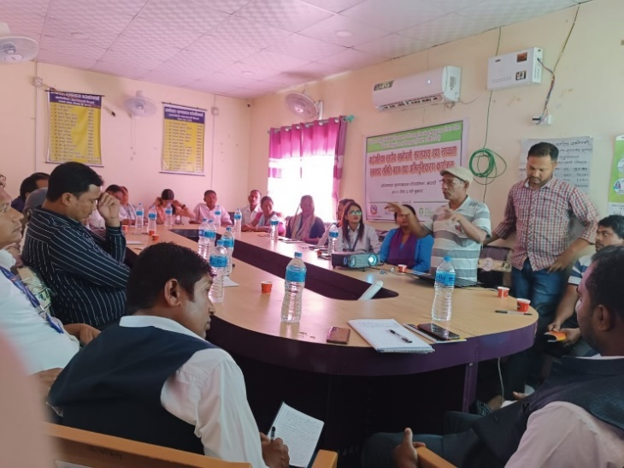
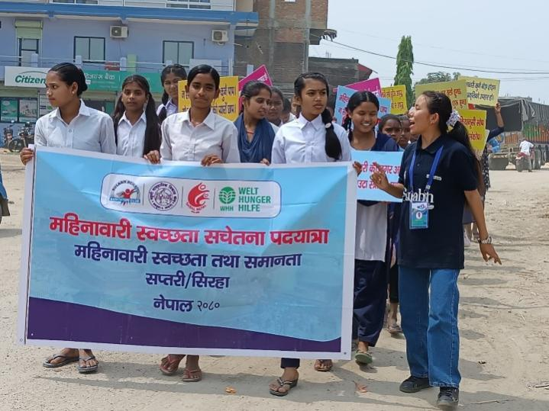
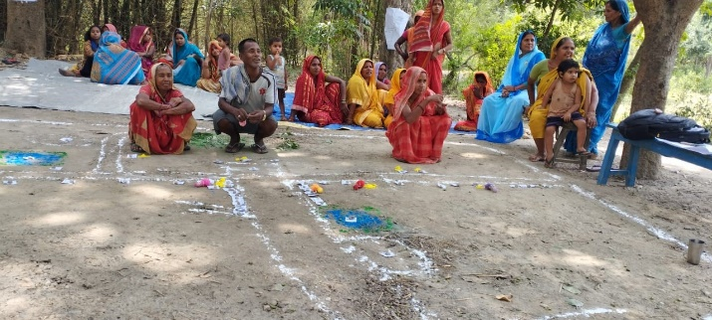
Pic 6: MCDC Executive Director clarifying Roles and responsibility during RM-WASH-CC formation
Pic 5: SAG formation at Goth Yadav Tole, Rajghad Rural Municipality-01
Pic 3 IPRA exercise at Community
Pic 4: Group photo after completion of plantation at Shree Aadharbhut Vidyalaya Chhapki Bakdhuwa, Agnisair Krishna Sawaran Rural Municipality-05
Pic 1: Students participation in the rally before the MHM workshop at Pato Bazar, Dakneshwori RM.

