ædlxnf k'?ifsf] ;+o"Qm k|of;, x'g ;S5 ;d'bfosf] ljsf;Æ
dx'nL ;fd'bflos ljsf; s]Gb|
cUgL;fO{/ s[i0ff;j/0f uf=kf=– %, asw'jf, ;Kt/L
#! cf}+ jflif{s k|ltj]bg @)*!÷)*@
!_ k[i7e'dL M
dx'nL ;fd'bflos ljsf; s]Gb| -Pd=;L=l8=;L=_ Ps u}/ ;/sf/L ;+:yf xf] . of] ;+:yf u}/ ;/sf/L ;+:yf P]g @)#$ cGt/ut ;Kt/L lhNnfsf] lhNnf k|zf;g sfof{nodf b"O{ aif{sf] nfdf] ;+3if{ kl5 @)%! ;fn h]i7 #) ut] ljlwat dx'nL o'jf Snjsf] gfdn] btf{ ePsf] Ps ljz'4 d'gfkmf /lxt u}/ ;/sf/L ;+:yf xf] . o;n] cfh #! j;Gt kf/ u/]/ #@ cf}+ aif{sf] ofqfdf kfO{Nff /fVg ;kmn ePsf] 5 . o; lhNnfsf] ;fdflhs If]qdf lzIffsf] gf/f lnP/ cfkmgf] ;fdflhs ;]jfsf] ofqf cuf8L a9fPsf] lyof] . g]kfnsf] u|fld0f ;fd'bfodf lzIff / hgr]tgfsf] cefjn] b]zdf u/LjL / las[lt ePsf] dxz'z u/L lzIff If]qnfO{ cufl8 a9fPsf] lyof] / ( uf= lj=;=df #& j6f k|f]9 lzIff / ( j6f jfn lzIff ;+rfng u/]sf] lyof] t/ vf;} pknAwL ePsf] kfO{Pg. pgLx?nfO{ ;j eGbf klxn] ufF;sf] vfrf] /x]sf] b]lvof], k]6df g} 5}g eg] k9fO{ / l;sfO{ tkm{ Wofg guPsf] b]lvof], h;sf] kmn:j?k ;fIf/tf k|ltzt tyf lzIff ;DaGwL hfu[lt Nofpg lgs} sl7gfO{ ePsf] lyof] .
jf:tjdf ufF;sf] vfFrf] ePsf] AolQmsf] nflu ljsf; eGg] zAb w]/} k5fl8sf] s'/f xf] . h;nfO{ klg klxn] vfgf To; kl5 skf; / clg af; sf] cfaZoQmf x'g cfp5 . cfwf/e't cfaZoQmf g} ;aeGbf d'Vo vFfrf] /x]sf] dx;'z ub}{ @)%$ ;fnaf6 u|fdl0f ;fd'bfodf ;+u7g, art, k'GhL ,zLk / Aoj;fo tkm{sf] ;f]rnfO{ cuf8L ;fb}{ ;d'x art tyf ;fd'lxs C0f sfo{qmdsf] ;fy} ;fIf/tf sfo{qmd klg z'?jft ul/of] .
o; ;d'x art tyf C0f sfo{qmdsf] ofqf ubf{ ub}{ laleGg l;sfO{ l;Sg] cj;/ kfO{of] / u/Lj ;fd'bfosf] rfxgf, cfaZoQmf / dfFu cg';f/ @)%* ;fn >fj0f dlxgfaf6 u|fld0f k4tL cg';f/ n3'ljt sfo{qmd ;+rfng uof]{ . o; n3'ljt sfo{qmdnfO{ 5'6} sDkgL P]g cGt/ut btf{ u/fO{ 3 ju{sf] n3'ljt a}+ss?kdf :yfkgf u/L @)&) ;fn >fj0f ! ut] jf6 x:tf/0f ul/Psf] xf] / clxn]] /fli6«o :t/sf] ljQLo ;+:yfsf] ?kdf ;+rfng /x]sf] 5 .
@_ sfg'gL dfGoftf tyf cfa4tf M–
s_ lh=k|=sf= ;Kt/L , btf{ g+ –@# -@)%!÷)@÷#) _
v_ ;=s=k=cfa4tf g+=– #@^) -@)%@÷)^÷$ _
u_ ljQLo dWo:tf cg'dlt kq g+=–^ -@)%&÷)@÷#) _ g]kfn /fi6« a}+s sf7df08f}++ .
3_ u}/ ;/sf/L ;+:yf dxf;+3 .
r_ ;+:yfsf] Eof6 g= #)!&#@^@@ -cfGqLs /fh:j sfof{no nxfg l;/xf , @)&#÷!!÷!&_

#_ cGo lgoldt ug'{ kg]{ clgjfo{ sfo{ M–
cl3Nnf] aflif{s ;fwf/0f ;ef ldlt M– @)*!÷(÷!# ut]
clGtd n]vf kl/If0f ePsf] ldlt M– @)*@÷%÷!@ ut] .
;+:yfsf] clGtd gljs/0f ePsf] ldlt M– @)*!÷^÷#) ut]
$_ ;+:yfsf] kl/snkgf, cleofg, nIo / p4]Zo ( Organization VMGO )
$=! kl/sNkgf (Vsion):
;+:yfut lbuf] ljsf;sf] ;fy} ul/a, ljKkGg, lkl58LPsf] u|fld0f ;fd'bfosf] ;[hglzn, :jfanDjL tyf ;Dd'gt ;dfhsf] :yfkgf ug'{ g} ;+:yfsf] kl/sNkGgf xf] .
$=@ cleofg (Mission):
;+:yfn] b]zdf ljwdfg u/LjL Go'gLs/0f ug{ u|fld0f ;fd'bfosf] ljsf;sf] nflu :yfgLo >f]t, ;fwg / >dsf] clwQmd kl/ rfng ug]{ o; ;+:yfsf] cleofg xf] .
$=# nIo -Goal_
:yfgLo ?kdf ;LdfGts[t / Go'g >f]t;fwg ePsf, sdhf]/ kx'Fr ePsf tyf hf]lvddf /x]sf;d'bfo leq nlIft tyf hf]lvddf /x]sf hg;+Vofsf] () k|ltzt ;Dd ;d'bfox?nfO{ ;fdflhs ;]jf k|bfg ug]{ Ps lbuf] ;+:yf k|j4{g ug]{ p2]Zon],, plgx?sf] clwsf/ ;'lglZrt ub}{ cfwf/e't dfgljo cfjZoQmfx?k"/f ug{ Ifdtf ljsf; ub}{ ;fdflhs kl/rfng ug]{ .
$=$ ;+:yfsf] p2]Zo- Objectives_
s_ b]zdf ljwdfg u/LjL Go'gLs/0f ug{ u|fld0f ;fd'bfosf] ljsf;sf] nflu :yfgLo >f]t, ;fwg / >dsf] clwQmd kl/rfng ub}{ k5L k/]sf jf kfl/Psf nlIft ;d'x jf ju{nfO{ z;lQms/0f ub}{ ljleGg cfofdx?sf] dfWodAff6 u/LjL Go'gLs/0fdf of] ubfg k'¥ofO{ /fi6««sf] lbuf] ljsf; nIo -SDGs_ k/Lk'tL{ ug{ ;xof]u ug]{ o; ;+:yfsf] d'Vo p4]Zo xf] .
v_ ljkGg ju{ / ;d'bfosf] cfly{s ljsf;, ef}lts ljsf;, dfG;Ls :jf:Yo ;'wf/, aftfj/0f ;+/If0f, dfgljo ;xof]us]f sfo{qmdx? ;+rfng ug]{ .
u_ ;du| ;fdflhs ljsf;sf] lgldQ dlxnf tyf afnaflnsf clwsf/ ;+/If0f, ckf+utf ePsf JolQmx?sf] clwsf/, h]i7 gful/s clwsf/, o'jf clwsf/, dfgj clwsf/ ;+/If0f / lzIff tyf l;k ljsf; k|j4{g ug]{ .
$=! p4]Zo kl/k'tL{sf] nflu ul/g] sfo{ tyf lqmosnfkx? M
;dfGo lqmofsnfkx?M
-!_ hnjfo' k/Ljt{g / ljkb\ hf]lvdaf6 x'g] gsf/fTds k|efjnfO{ /f]Sg cg's'ng, ljkb\ hf]lvd Go"lgs/0f tyf Joj:yfkg / hn h+un hldg ;+/If0f ;DalGw gljgtd k|of;x? ug]{ .
-@_ :yflgo, If]qLo, /fli6«o, cGt/fli6«o, ;/sf/L, u}/ ;/sf/L ;+3 ;+:yfx?;+u ldnL ;fd'bflos ljsf;sf] sfo{qmd th'{df u/L ljleGg of]hgf / kl/of]hgfx? ;+rfng ug]{ .
-#_ hgzlQm ljsf; tyf kl/rfngsf] nflu ljleGg k|sf/sf] tflnd, cled'lvs/0f, ljlto ;fIf/tf, hgr]tgf clea[l4 ug]{ sfo{qmdx? th'{df u/L ;+rfng ug]{ .
-$_ u/LjL lgjf/0fsf] nflu cfo cfh{g ug]{ ;d'x u7g ug]{, ;xsf/L u7g ug{], k|j4[{g ug{ / ljsf; ug{ cfjZos ;xof]u ug]{ .
-%_ ljleGg ;+3 ;+:yf;+u cfk;L ;xof]u / ;Nnfx ;'emfjsf] cbfg k|bfg ug]{ .
-^_ dfgj clwsf/, dlxnf clwsf/ tyf jfn aflnsf / plgx?sf] clwsf/ ;+/If0f tyf ljleGg ljifodf k}/jL tyf tyf hg jsfnt ;+rfng ug]{ .
k|fyldStfsf lqmofsnfkx?M
o; ;+:yfsf] p4]Zo kl/k'tL{ ug{ / nIo k|fKtLsf] nflu b]xfo adf]lhdsf] If]qdf k|fyldStf x'g] 5 .
-!_ dlxnf ju{sf] pTyfg / ;zlQms/0fsf] nflu lzIff, ;fdflhs ;xeflutf n}+lus ;dtf tyf ;dfgtf, dlxnf lx+;f, dlxnf clwsf/, df}lns clwsf/ nufot cfo a[l4 x'g] sfo{qmdx? ;+rfng ug{ clek|]l/t ug]{ / cfjZos ;xof]u ug]{ .
-@_ vfg]kfgL ;/;kmfO{ tyf :jR5tf k|j4{g, kf]if0f tyf kf]if0f lzIff, lszf]/ lszf]/L, dlxnf tyf k|hgg :jf:y, afn ljsf;, dfq[ lzz' :ofxf/, hn h+un / e'dL ;+/If0f tyf Jojl:yt a;f]af; clwsf/sf] nflu cfaZos sfo{qdx? ;+rfng ug]{ .
-#_ hg ;xeflutfd'ns of]hgf th"{df, hnjfo' k/Ljt{g / ljkb\ hf]lvdaf6 x'g] gsf/fTds k|efj Go"gLs/0f, ljkb\ hf]lvddf k/]sfx?sf] p4f/ ;xof]u tyf k'g:yf{kgf h:tf lqmofsnfksf] nflu ;fdflhs kl/rfng tyf ;xhLs/0f sfo{ ;+rfng ug]{ .

%_ ;+:yfsf] ;fwf/0f ;ef M–
%=!_ ;fwf/0f ;efsf] z'ef/De tyf v'Nnf zq M
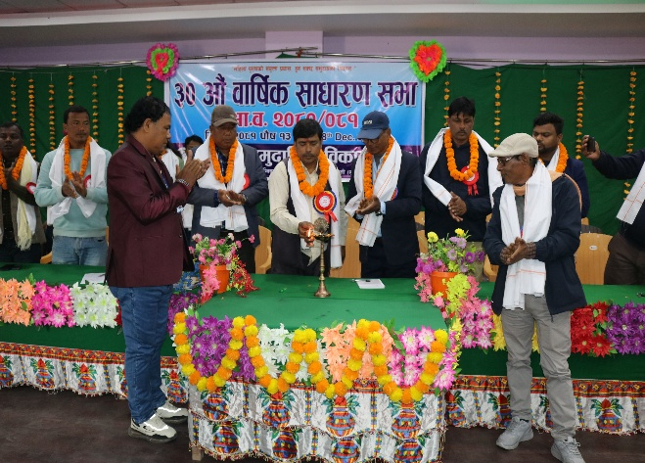
;+:yfsf] k|d'v c+u eg]sf] ;fwf/0f ;ef xf] / of] ;+:yf :yfkgfsfn b]lv jflif{s ?kdf lgoldt?kdf jflif{s ;fwf/0f;ef cfof]hgf ub}{ cfO{/x]sf] 5 eg] k|lt # jif{df clwj]zg ;ef x'g] k|fAwfg eP adf]lhd lgoldt ?kdf eO{ /x]sf] ;j}df ;j{ljlbt} 5 . pQm ;efdf ;+:yfsf] sfo{ k|ult, cfly{s k|ltj]bg tyf efjL of]hgfx? k|:t't u/L kf/blz{tfsf] jftfa/0f agfpg oxfFx?sf] ;Nnfx ;'emfj tyf lnO{ cfuf8L a9\g ;kmn ePsf] 5 . clGtd jflif{s ;fwf/0f ;ef ldlt @)*! k'; !# ut] cWoIf >L ZofdsfGt rf}w/L Ho'sf] cWoIftfdf ;Kt/L lhNnfsf] lhNnf ;dGjo ;ldt k|d'v >L lzj gf/fo0f Ho'sf] k|d'v cfltYodf ;j} ;/f]sf/jfnfx?sf] pkl:lyltdf ;';DkGg ePsf] lyof] . h;df lhNnf kqsf/ dxf;3sf] k|ltlglw, :yfgLo a'l4hLjL, :yfgLo ;+3 ;+:yfsf] k|ltlglwx?n] z'esfdgf dgtJo JoQm u/sf lyP eGg] cfufdL 5gf}6 x'g] gj sfo{ ;ldltnfO{ ;kmn sfo{sfnsf] cu|Ld z'esfdgf klg JoQm u/]sf lyP . 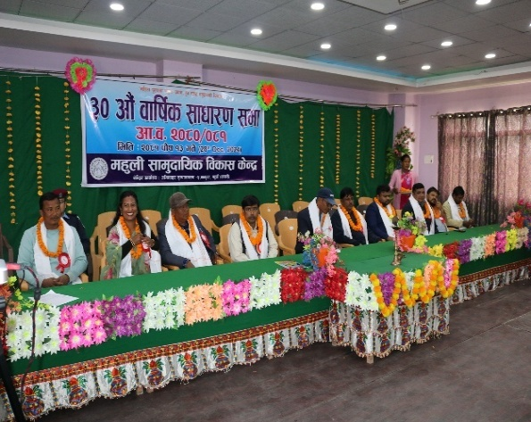
#) cf}+ ;fwf/0f ;efdf k|d'v cltly lhNnf ;dGjo ;ldlt k|d'v >L lzjgf/fo0f ;fxjf6 pb3f6g . /sfo{sf/L ;lrj >L k|e' gf/fo0f rf}w/Ljf6 k|ult k|ltj]bg k|:t't

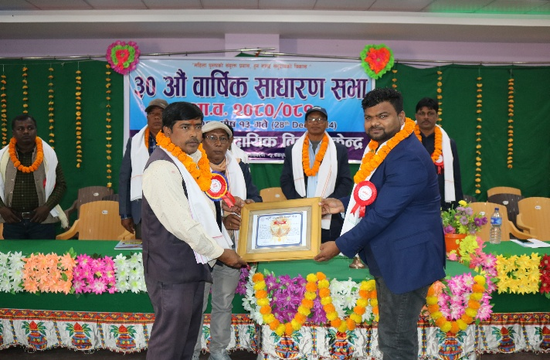
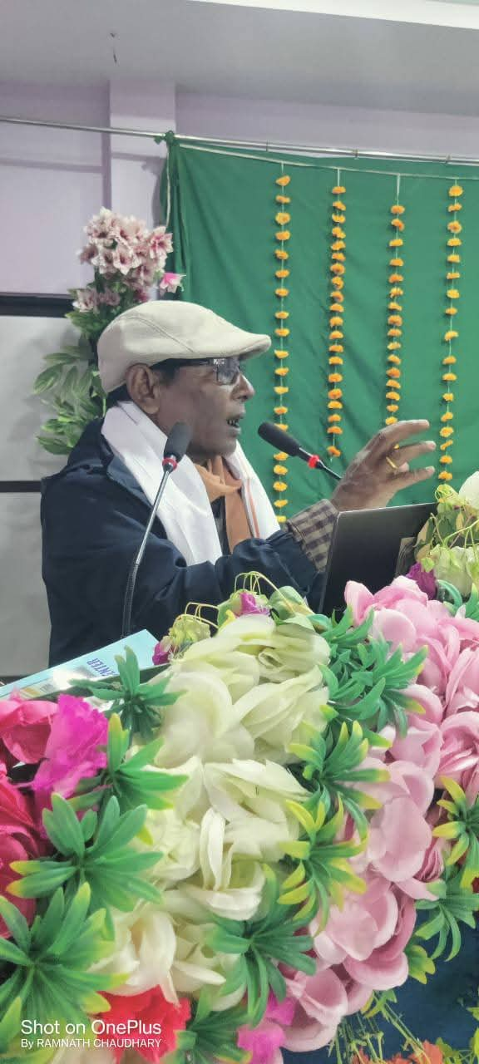

sfo{sf/L ;lrj >L k|e' gf/fo0f rf}w/Ljf6 k|ult k|ltj]bg / cfly{s k|ltj]bg k|:t'tLs/0f ul/b}

;fwf/0f ;efdf cltlyx?nfO{ ;dfg ul/b}

%=@_ ;fwf/0f ;ef @)*!÷@)*@ df k]z eO{ cg'df]bg ul/Psf k|:tfjx?
o; cf=j=sf] nflu ;fwf/0f ldlt @)*!÷(÷!# df kfl/t u/]sf sfo{qmdx? o; k|sf/ /x]sf] 5 .
s_ ;dfGo k|:tfjx?
!_ jflif{s k|ult k|ltj]bg tyf cfly{s k|ltj]bg kfl/t
@_ @)*! ÷@)*@ sf] jflif{s lglt tyf sfo{qmd kfl/t
#_ @)*!÷)*@ sf] clfy{s sf/f]jf/sf] nflu n]vf k/LIfssf] lgo'lQm jf clwsf/ k|Tofof]hg
ljz]if k|:tfjx?
!_ lgodfjnL z+;f]wg tyf cg'df]bg ,
@_ ljwfg ;+zf]wg tyf d:of}bf ;ldlt u7g
#_ k'/fgf] sfo{ ;ldltsf] la36gsf] 3f]if0ff / gofF sfo{ ;ldltsf] rog tyf 5gf]6
$_ ;fwf/0f ;efsf] lg0f{o k'l:tsf aGb ug]{ k|ltlglwsf] 5gf}6
%_ ;fwf/0f ;efsf] ;dfKtLsf] 3f]if0ff M
%=# ;fwf/0f ;efsf] ;b:ox? M
qm=;= | ljj/0f | ;Vof | blnt | yf?, hghftL | cGo | d= | k'= | ljz]if
! | ;+:yfks ;b:o | & |  | & |  |  | & | )
@ | cflhjg ;b:o | #! | @ | @# | ^ | ( | @@ | )
# | ;fwf/0f ;b:o | %) | ! | $! | * | @# | @& | )
 | hDdf | ** | # | &! | !$ | #@ | %^
 |  |  |  |  |  | #^.#^Ü | ^#.^$Ü

%=$_ #) cf} ;fwf/0f ;efjf6 5gf]6 tyf rog ePsf gofF sfo{ ;ldlt kbflwsf/Lx? M
qm=;= | kb | gfd | lnË | hfthftL | at{dfg 7]ufgf | ;b:otf
! | cWoIf | >L /fdnug d08/ | k'?if | cfbLjf;L, hghftL, yf? | c= s=;= ^ /tjfnf | cflhjg
@ | pkfWoIf | >L ;fljqL rf}w/L | d= | cfbLjf;L, hghftL, yf? | c= s=;= % asw'jf | cflhjg
# | dxf;lrj | >L rGb|dgL k|;fb d08/ | k'= | cfbLjf;L, hghftL, yf? | /fhlj/fh g= % | cflhjg
$ | sfo{sf/L ;lrj | >L k|e' gf/fo0f rf}w/L | k'= | cfbLjf;L, hghftL, yf? | c= s=;= % asw'jf | ;:yfks
% | ;b:o | >L cIdLtnfn rf}w/L | k'= | cfbLjf;L, hghftL, yf? | c= s=;= % asw'jf | cflhjg
^ | ;b:o | >L b'uf{gGb rf}w/L | k'= | cfbLjf;L, hghftL, yf? | c= s=;= % ledf/ | ;fwf/0f
& | ;b:o | >L zl;tf s'df/L rf}w/L | d= | cfbLjf;L, hghftL, yf? | c= s=;= % ledf/ | ;fwf/0f
* | ;b:o | >L dfwj k|;fb cfrf{o | k' | afx'g | c= s=;= ^ df]xgk'/ | ;fwf/0f
( | ;b:o | >L lg? b]jL ;bf >[lifb]j | d= | blnt | c= s=;= % ledf/ | ;fwf/0f

^_ sfo{ ;ldltn] k'/f u/]sf] lhDd]jf/L M
o; cf=j= @)*!÷@)*@ sf] cAwLdf hDdf !& j6f a}7sjf6 @)*!÷@)*@ sf] ;fwf/0f ;efn] lbPsf] lgb]{zg tyf kfl/t ePsf] of]hgfx? ;fGbeL{s ljifox?df 5nkmn tyf lg0f{o u/L sfo{qmdx?nfO{ k|efjsf/L ;fy ;+rfng ug{ ;kmn ul/of] . ;fwf/0f ;efn] lbPsf] sfo{ tyf lhDd]jf/Lx? tyf sfo{qmdx? o; calwdf k'/f ePsf] 5 . pQm jif{sf] cfly{s sf/f]jf/ /lhi6f8{ rf6{8 n]vf k/LIfs P a+zn P08 Pzf]l;P6sf] cZjgL a+zn Ho'jf6 n]vf k/LIf0f eO{ ;s]sf] / lgoldt ?kdf n]vf kl/If0f x'b} cfPsf] Aoxf]/f cg'/f]w 5 .
;+:yfsf] b/f] tyf lbuf] ljsf; / b]zdf gfd kl/lrt u/fpg'sf] ;fy} ;+:yfn] lnPsf] p4]Zo cg';f/ ;do ;dodf ;fd'bfosf] cfaZoQmf cg';f/sf] sfo{qmdx? NofO{ u|fld0f :t/sf] ljsf;nfO{ ;3fpb} cfPsf] 5 . o; ;+:yfn] ljut @%jif{df s}of} sfo{qmdx? ;kmntf;fy ;DkGg u/L ;s]sf] 5 . s]xL sfo{qmdx? ;+rfng cj:yfdf klg /x]sf] 5 . cf=j= @)*@÷)*# df ;+rflnt sfo{qmdx? tyf lqmofsnfkx? o; k|sf/ /x]sf 5g\ .
&_ ;xsfo{ / ;fe]mbf/L ePsf] ;+3 ;+:yfx?
;xsfo{

*_ o; dx'nL ;fd'bflos ljsf; s]Gb|sf] Pltxfl;s ljj/0f M
dx'nL ;fd'bflos ljsf; s]Gb| cgf}krfl/s ?kdf @)$* ;fndf cfkmgf] ufFp7fFpdf s]xL u/f} efjgfjf6 hfu[t eO Pp6f ;+u7gsf] cjwf/0ff cfPsf] xf] . ufFpsf] jf6f] 3f6f] , lzIffsf] cfefj / u/LjLsf] ;d:ofsf] sf/0fn] k|/]0ff kfPsf] xf] . To;}n] egfO{ 5, ;d:of tyf cfaZoQmf g} x/]s gofF ;f]rsf] k|]/0ff xf] . o;sf] lj:t[t ljj/0f cg';'rL $ df b]vfOPsf] 5
(= o; ;+:yfsf] o; k|ltj]bg cf=j= sf] k|fKt cfly{s >f]t tyf cfo M
s_ cfGtl/s >f]tM !_ ;b:otf z'Ns , a}+s Jofh, ljljw ;]jf z'Ns bfg rGbf , nufgL nfef+z .
v_ jfXo ;fd'bflos ljsf; sfo{sf] nflu kfpg] bfqL ;++3 ;+:yfjf6 k|fKt ;xof]u .
o; cf=j=sf] cfo >f]t
cfGtl/s >f]tjf6 ? @#,%^,)%!.%^
jfxo >f]t Xoflj6\of6 g]kfnjf6 ? !,($,$*)*(.%&
afxo >f]t j]N6x+u/ lxNk]jf6 ? @(@@^($).))
lji0f'k'/ uf=kf= jf6 ? $^&))).))
hDdf cfo %,!$,(*,)*!.!#
sfo{qmd nufot sd{rf/L tyf sfof{no ;+rfng hDdf ljQLo vr{ ? %!@$&%*(.(#
ljQLo ;/Kn; ? @%)$(!.@)
;Dklt xf|;df u}/ ljlto vr{ ? !$(@$*(.^*
;+:yfut gf]S;fg lx;fj ? !@$!((*.$*

!) = k|ltj]bg aif{sf] ;fem]bf/ ;+:yf tyf sfo{qmd M—
o; k|ltj]bg jif{df o; ljsf; s]Gb|n] @ j6f ljsf;] ;fem]bf/ ;+:yf;+u ;fem]bf/Ldf d'Vo ?kdf @ j6f kl/of]hgf ;+rfng ug{ ;kmn ePsf] 5 .
qm=;= | ;fem]bf/ ;+:yf | sfo{qmdx? | kl/of]hgfsf] ah]6 | sfo{If]q
! | Habitat Nepal , (HFH) | !_ ;'/lIft cfjf; ,lxN6L  @_ afhf/ / ahf/Ls/0f lxN6L  #_ pTyfgzLn  $_k"jL{ g]kfnsf] ljkb Go'gLs/0f ;fdflhs ;dfj]zLs/0f kl/of]hgf | o; cfj= sf] vr{ ug]{ cg'dflgt @ s/f]8 #& nfv | ;Ktsf]zL / zDe'gfy gu/kflnsf tyf cUgL;fO/ s[i0ff ;j/0f ufFpkflnsf
@ | Welthunger-hilfe (WHH) | !_ ;fd'bfosf] cu'jfO{df ;/;kmO tyf hgr]tgf ljsf;  @_ vfg]kfgL ;/;kmfOdf Ifdtf clea[l4 tyf k|0ffnL ljsf;  #_ u|fld0f vfg]kfgL tyf :jf:y s]Gb|sf] vfg]kfgL tyf dd{t ;Def/.  $_ laBfno vfg]kfgL tyf ;/;kmfO{ | o; cf=j= sf] vr{ ug]{ cg'dflgt jh]6 $ s/f]8 . | gu/kflnsf ;Ktsf]zL, 8fSg]Zj/L ufFpkflnsf cUgL;fO/ s[i0ff ;j/0f, /fhu9 / ljif0f'k'/

!!_ kl/of]hgf cg';f/sf] lj:t[t lqmofsnfksf] cfwf/sf] ljj/0f M
!!=!_ ;'/lIft cfjf; kl/of]hgf M
s_ blnt ;'s'djf;L tyf cfjf; ljlxgx?sf] nflu ;'/lIft cfjf; M
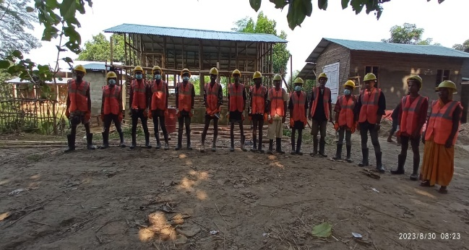
o; cf=j=df Xoflj6\of6 g]kfn / :yfgLo txsf] ;+o'Qm ;fem]bf/Ldf lxN6L kfmpg8]zgsf] ;xof]udf o; ljsf; s]Gb|n] o; ;Kt/L lhNnfdf $% blnt , clt ljKkg tyf e'dLxg tyf cfjf; ljlxg kl/jf/x?nfO{ :yfgLo >f]t ;fwgsf] pRrtd k|of]u x'g] pkrf/ u/]sf] jfF;jf6 ;'/lIft cfjf;sf] ;xof]u ug]{ /x]sf] lyof] . h;df ;Kt/L lhNnfsf] zDe'gfydf jf8{ g= ! df !) / ;Ktsf]zL g=kf=jf8{ g= &, * / ( df @@ kl/jf/ u/L hDdf #@ cfjf; ljlxg / e'ldlxg blnt tyf hghftL kl/jf/x?sf] nflu ;'/lIft cfjf; z'?jft u/]sf] 5 . h;df :yfgLo tx Xoflj6\of6 g]kfn / o; ljsf; s]Gb|sf] lqkIfLo ;Demf}tf adflhd :yfgLo >f]t ;fwgsf] clwQmd k|of]u /x]sf] 5 . l8hfOg Oli6d]6 cg';f/sf] Pp6f 3/sf] 3/sf] jh]6 3/ wgL >dbfg jfx]s ? $(@))).)) /x]sf] lyof] eg], @ nfv kl/of]hgfjf6 tyf @ nfv (@ xhf/ :yfgLo txjf6 nufgL /x]sf] 5 .
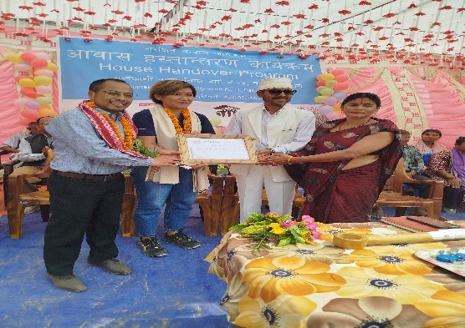
v_ ;'/lIft cfjf; x:tfGt/0f M
o; k|ltj]bg cf=j= ljutdf k"0f{?kdf t}of/ ePsf # j6f ;fd'bfosf] ;'/lIft cfjf; ;DalGwt g=kf= uf=kf= sf] dfkm{t ;Dalgwt 3/wgLnfO{ x:tfGt/0f ug]{ sfo{qmd ;DkGg ul/of] . h;df cUgL;fO/ s[i0ff ;j/0f uf=kf= jf8{ ! / @ u/L $! kl/jf/nfO{ tyf ;Ktsf]zL g=kf= sf] jf8{ g= $ l:yt sfdt6f]nsf] blnt ;fd'bodf !* kl/jf/ u/L %( kl/jf/nfO{ Xoflj6\of6 km/ Xo'dflg6L OG6/g]zgnsf pkfWoIfsf] k|d'v cltYodf e]; Eof lkmnLlkG;sf] k|ltlglw, Xoflj6\of6 g]kfnsf] k|ltlglw :yfgLo txsf k|ltlglw nufot ;/f]sf/jfnfx?, kqsf/x? ;lxtsf] pkl:yltdf Ps ;df/f]x ljr cjf; x:tfGt/0f ul/of] .
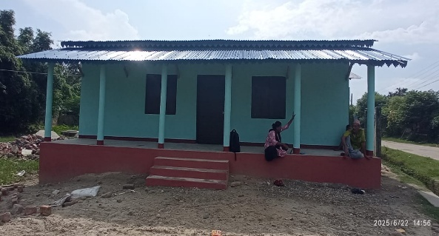
u _ ;fd'bflos ejg cyf{t ;fj{hlgs ejg M
hnjfo' k/Ljt{gsf] sf/0fn] kg]{ jftfa/0fLo c;/nfO{ Wofgdf /fvL lrdgLnfO{ lg?T;flxt ug{sf] nflu :yfgLo >f]t ;fwgnfO{ dxTj lbO{ kf]nd s+s[6sf] k|f]T;fx0f ug]{ pkrf/ ul/Psf] af; k|of]u u/L cfjf;sf] cfo' a9fpg] tyf jftfa/0fLo ?kn] klg ;sf/fTds c;/ x'g] k|fs[lts tfkqmdnfO{ ;se/ lgo'gLs/0f ug{sf] nflu pkrf/ u/]sf] af;jf6 ;Ktsf]zL g=kf= jf8{ —# df / zDe'gfy jf8{ — @ df Ps÷Ps j6f @)ˣ#)Ö ^)) ju{ lkm6sf] gd'gf:j?k ;fj{hlgs ejg lgdf{0f ul/ Psf] 5 . h;sf] k|lt ejg ? &@%))).)) /x]sf] 5 .

!!=@_ :yfgLo >f]t / ;fwg tyf pkrf/ u/]sf] afF;sf] afhf/ / ahf/Ls/0f M
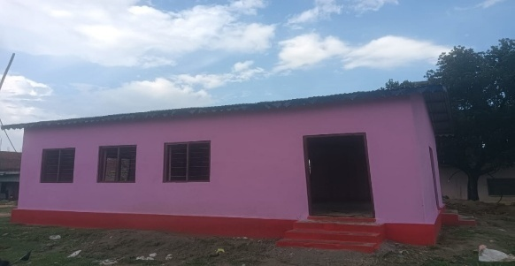
s_ pkrf/ u/]sf] afF;sf] k|aB{g tyf k|df]zg M
To;} u/L sd cfo ePsf JolQm ljz]ifn] klg pkrf/ ul/Psf] af; k|of]u u/L cfjf;x? lgdf{0f ug]{ xf};nf a9fpg] p4]Zosf] ;fy o; k|ltj]bg jif{df % hgf Go'g cfo >f]t ePsf Jolqmx?nfO{ ? Ps nfv a/fj/sf] ;xof]u u/L pkrf/ af;sf] k|of]usf] Ps gd'gfsf] ?kdf ;+rfng ul/of] .
v_ afF;sf] lhNnf b/ efp M df sfg'gL dfGotfsf] nflu lhNnf :t/ b]lv kflnsf :t/sf] ;/f]sf/jfnf ;DalGwt lgsfox?df ;dgdofTds e'ldsf lgjf{x ub}{ af;sf] ;/sf/L b/ efp sfod xf]; / pkrf/ u/]sf] jfF;sf] klg b/ efp sfod xf]; eGg] p4]Zon] lhNnf :t/jf6 lg0f{o ;d]t eO{ ;s]sf]n] Ps r/0fsf] sfo{ ePsf] dflgg] 5 .
u_ afFF; s]Gb|nfO{ k'/s ;xof]u k|bfg M af;sf] pkrf/ s]Gb|nfO{ km;6fpg ;fgf] ;fgf] pks/0fx? tyf k"jf{wf/sf] nflu k'/s ;xof]u u/Lb} cfPsf] / To;n] afF; pkrf/ s]Gb|x?nfO{ k|fT;fx0f ldNg], k'/s ;xof]un] af; s]Gb|sf] Jofkfl/s of]hgfdf ;sf/fTds k|efj k/]sf] cj:yf /x]sf] 5 .
3_ pkrf/ u/]sf] k|of]usf] nflu k|rf/ k|;f/ M hnjfo' kl/jt{gsf] sf/0fn] ljZj g} k|efljt ePsf] cj:yf 5. kSsL ;+r/gfx? , lrdgLsf] 3F'jf , ;8sjf6f]sf] k|b'if{0f tyf zx/ b]lv cj u|fld0f ;fd'bfox?df kSsL ejgx?sf] sf/0f tfkqmd k/fjt{gsf] sf/0fn] klg hnjfo' kl/jt{g eO /x]sf] cj:yf 5. To;}n] lrdgLjf6 pTkflbt O§fsf] k|of]u /fsf}, lrDgL aGb x'G5 , :yfgLo ;fdu|x? , pkrf/ u/]sf] afF;sf] k|of]ujf6 lb3{sflng / lbuf] ;+r/rgfx? agfp eGg] d'n gf/fsf] ;fy , krf{, kDkn]6;\, ;8s gf6s, Pkm Pdx?, dfOlsËJff6 k|rf/ k|;f/x? ul/of] eGg] 7fFp 7fpdf xf]l8{Ë nfUg] d]nf ahf/x?df afF;jf6 pTkflbt a:t'x?sf] gd'gfx?sf] k|bz{gx? ul/of] .
!!=#_ pTyfgzLn kl/of]hgf M u|fld0f ;fd'bfodf clt u/Lj tyf ljKkg kl/jf/x?nfO{ pgLx?sf] hLjg:t/df Jojxfl/s kl/jt{gsf] nflu Ps k'/s ;xof]usf] ?kdf of] k'/s kl/of]hgf ;+rfng ul/Psf] lyof] . ;'/lIft cfjf;n] 6fFpsf] dfly 5fgf lbG5 t/ To; ;fd'bfodf rflxg] clt cfjZos s'/fx? h:t} vfg]kfgsf] cfefj, ;'/lIft g'xfpg], dlxgfjf/Lsf] j]nf ;kmf;'Uw/ x'g], ks8f abNg] j]nfsf] cj:yfdf cln eP klg Standerise u/L hLjgz}nLdf kl/jt{g Nofpg] d'Vo p4]Zon] 9'jfg If]qdf Raised Hand Pump / cGo If]qdf Hand Pump sf] h8fg u/L kfgL k'tL{ ug{ ;xof]u ug"{sf] ;fy} g'xfpg] 3/x?sf] ;xof]u u/]sf] 5. To;}u/L xfnsf] cj:yfdf 3/ 3/df Ps ;'/lIft zf}rfnosf] cfjZoQmfnfO{ Wofgdf /flv c;'/lIft cj:yfdf /x]sf] zf}rfnox?sf] dd{t ;Def/sf] ;fy} k'g/ lgdf{0f u/L Ps ;'/lIft zf}rfnosf] Joj:yf ug{ ;xof]]u u/]sf] 5 . h;n] ubf{ hg ;fd'bfosf] zf}Gbo{tfsf] ;fy} klxrfg klg sfod ePsf] b]lvG5 .
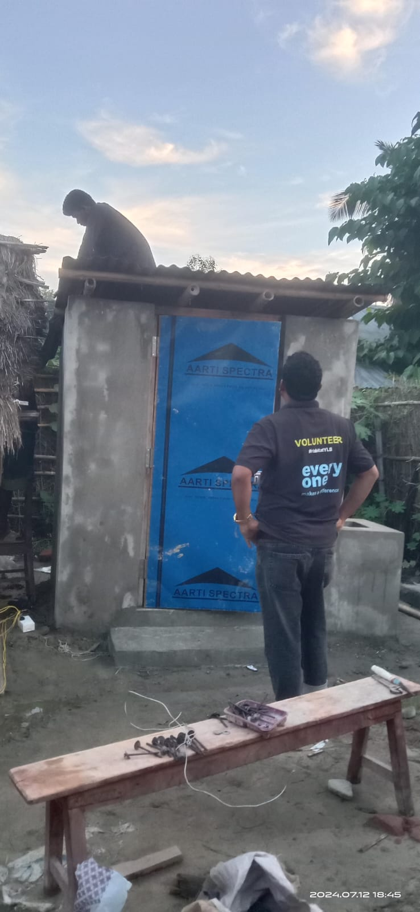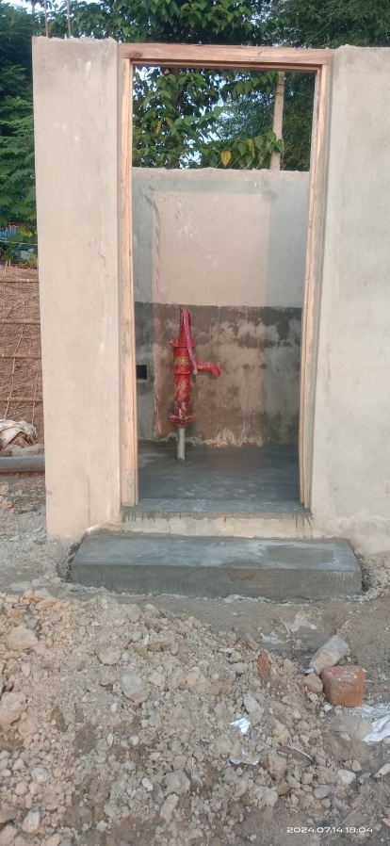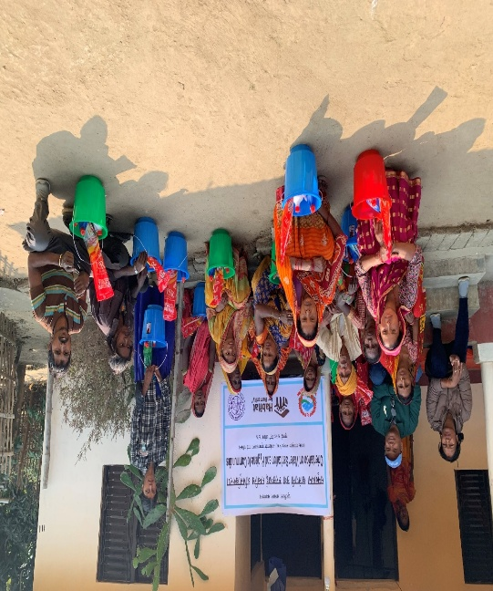
!!=$_ k"jL{ g]kfnsf] ljkb Go'gLs/0f ;fdflhs ;dfj]zLs/0f kl/of]hgf M of] kl/of]hgf g]kfnsf] k'jL{ efudf kg]{ ;Kt/L lhNnfsf] zDe'gfy gu/kflnsfdf bf]>f] km]hsf]?kdf ;+rfng ;kmntf;fy ;DkGg ePsf] xf] . o; kl/of]hgfsf] d'Vo p4]Zo kflnsf:t/df ljkb Joj:yfkgsf] nflu k"j{ t}of/L of]hgf b]lv sfof{Gjog;Dd blnt u/Lj, dlxnf k'?if, cfkfË, nf]kf]Gd'v hftL ;j} ju{ nufpt ;DalGwt If]qsf] ;/f]sf/jfnfx?sf] ;xeflutfdf of] kl/of]hgf ;+rfng ug'{ lyof] . o; kl/of]hgfdf kflnsfsf] ljkb Joj:yfkgsf] of]hgf adf]lhd sfof{Gjogsf] lqmofsnfkx? ;+rfng ePsf] lyof] h;sf] k'[0f{ :jfldTj / lhDd]jf/L ;dfj]lztfd'ns ;xeflutf k|0ffnLjf6 ;+rfng ePsf] lyof] .
pbfx/0f :j?k ufFpn]x?nfO{ hf]lvdsf] ljZn]if0fsf] cfwf/df cfjZoQmfnfO{ 5gf}6 u/L gd'gfsf] nflu pgLx?s} lg0f{o adf]lhd ;xof]usf] sfo{x? ;DkGg ul/of] .
s_ lqmofsnfkx?df M
kflnsf hgk|ltlgwLx?sf] ljr ;dGjofTds kl/rofTds uf]li7
jflif{s ljkb hf]lvd Go'gLs/0f of]hgf t}of/L tyf sfof{Gjog tflnsf lgdf{0f .
hf]lvd Go'gLs/0fsf] nflu gd'gf sfo{x?df ;xof]u M
!@=_ Up- Scaling WASH System Strenthening in the Terai kl/of]hgf M
o; kl/of]hgfsf] ;fwf/0f p4]Zo lbuf] vfg]kfgL ;/;kmfO{sf] k|0ffnLdf lbuf] Joj:yfkgsf] ljsf; ug{ hgjsfntsf] dfWodjf6 ;fd'bfosf] cu'jfO{df pknAw >f]t / ;fwgsf] pkof]u u/L vfg]kfgL ;/;kmfO{sf] If]qdf lbuf] Joj:yfkgsf] k|j4{g ug]{ /x]sf] 5 .
h; leq lgDg # j6f kl/0ffdnfO{ nlIft u/L of] vfg]kfgL ;/;kmfO{ kl/of]hgf ;+rfngdf /x]sf] 5 .
!@= !_ nlIft kl/0ffd -!_ ;fd'bfo :t/df M
;fd'bfosf] cu'jfOdf nlIft ;d'bfodf k"0f{;/;kmfO / :jR5tfdf ;'wf/ Nofpg] . ;'/lIft vfg]kfgLsf] jf/]df hgjsfnt ug]{ / clt cfjZos blnt÷ljKkg ;fd'bfodf vfg]kfgL kx'rsf] nflu lbuf] ljs]lG›t gd'gf vfg]kfgL cfof]hgfsf] Joj:yfkg ug]{ . ljBfnox?df vfg]kfgL tyf ;/;kmfO of]hgf lgdf{0fdf ;xof]u ug]{ / cfjZoQmfsf] cfwf/df lqmofsnfkx? ;+rfng ug]{ . % j6f kflnsfsf] !^%@(( hg;Vofdf ;/;kmfOsf] dxTj, cfjZoQmf / o; jf6 kg]{ ;jf{lug?kdf ;sf/fTds k|efjx?sf] jf/]df kl/0ffd ;lxt hgr]tgf ljsf; ug]{ /x]sf] 5 .
!@=@_ kl/0ffdd'lv lqmofsnfkx? M
s_ ;fd'bfosf] cu'jfOdf ;fd'bfo :t/df vfg]kfgL ;/;kmfO cEofg M
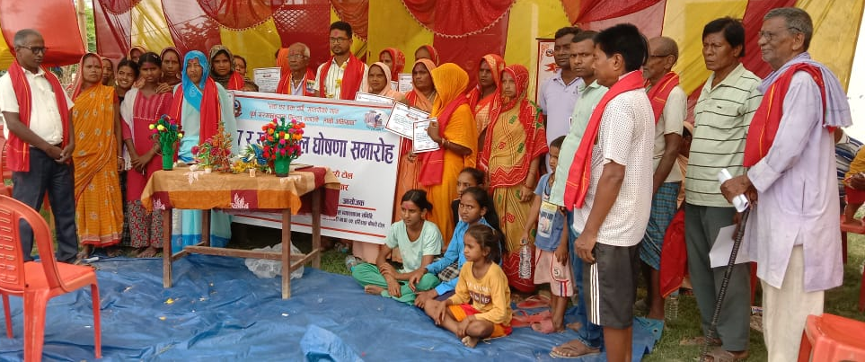
% j6f kflnsfsf] $) j6} j8f dWosf] *$ j6f 6f]ndf k"0f{ ;/;kmfOsf %±@ sf ;'rsx?df z]if0f z'?jft u/L pgLx?df 1fg / Ifdtfsf] ljsf; ug]{ tyf ;/;kmfO ;s[o ;d'x lgdf{0f u/L pgLx?s} g]t[Tjdf lgoldt ;/;kmfOsf] lqmofsnfkx? ;+rfng u/L Jojxf/df kl/jt{g ug]{ ;fd'bfo :t/sf] lglt lgod agfpg] , ;'rs lgwf{/0f ug]{ :j d'NofFsg u/L gDa/ lbg] sfo{sf] ljsf; ePsf] 5 eg] ;/;kmfO ;DalGw Jojxfl/s v]n, ;8s gf6s, krf{ kDkn]6dfkm{t k|rf/ k|;f/ klg ul/Psf] 5 . ;fd'bfosf] cu'jfO{df Ps 3/ Ps rkL{, jflx/ lbzf gb]lvg], 6f]n ;d'bfo tyf j/Lk/L ;kmf /fVg], 3/ glhs kfgL hDg glbg] h:tf lgodx? jgfP/ :jo+ cg'ud0f ug]{ / ;ldIff ug]{ tyf To;sf] ;fdwfg ug]{ Ifdtfsf] ljsf; ePsf] 5 . h;df oL lgDg d'Vo ;'rsx?x?nfO{ nlIft u/L ;d'xn] sfo{ ub{5g\ .
!= of]hgf th'{'{'{df tyf Joj:yfkg
@= rkL{sf] ;d'lrt k|of]u
#= JolQmut ;/;kmfO
$= ;'/lIft kfgLdf kx'Fr tyf k||of]]u
%= ;'/lIft vfgfsf] k||of]]u
^= 3/fo;L Pj+ ;+:+yfut ;/;kmfO
&= jftfj/0fLo ;/;kmfO
To;} u/L ePsf sfo{x?sf] ;d'bfos} cu'jfO{df ;do ;dodf 6f]n cg'ud0f, ;fd'bfodf ePsf ;'wf/x? tyf ;d:ofx?sf] lgl/If0f tyf cjnf]sg u/L a}7sdf 5nkmn ug]{ ul/G5 . of] cf=j= df ;/;kmfO ;s[o ;d'xsf] cu'jfO{df %±@ sf] ;'rssf] cfwf/df $# j6f 6f]n nfO{ k"0f{ ;/;kmfO tyf :jR5tf ;'wf/f]Gd'v 6f]n 3f]if0ff ug{ ;kmn ePsf] 5 .
v_ lszf]/L tyf dlxnfx?sf] dlxgfjf/L ;/;kmfO :jR5tf M $) j6} j8fsf] dlxgfjf/L pd]/ ;d'xsf] lszf]/Lx?nfO{ dlxgfjf/L jf/] ;r]tgfd'ns tflndx?, 3/]n' ;/;kmfOsf] pkfOx?, dlxgfjf/Lsf] sf/0fn] ;fdfhdf b]lvPsf e|dfTds ljrf/x?nfO{ ;sf/fTds agfpg] lsl;dsf] v]nx?, lqmofsnfkx? ;+rfng ul/of] / o;n] ;/;kmfO tyf :jR5tfdf ;'wf/ ePsf]5 .
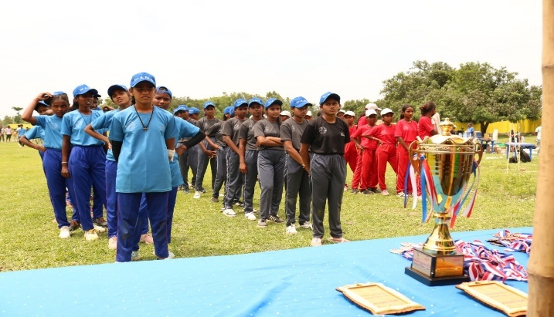
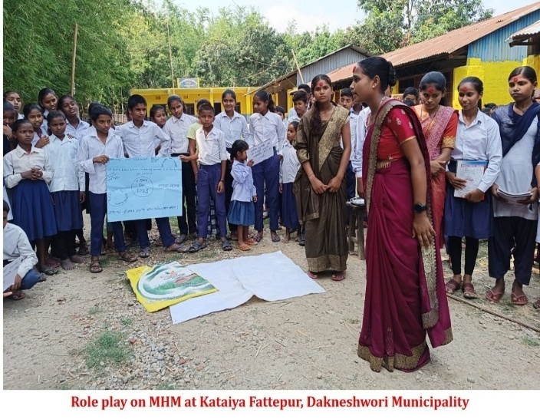
u_ jf8{ :t/Lo vfg]kfgL ;/;kmfO ;ldIff M o; ljsf; s]Gb|n] vfg]kfgL ;/;kmfOsf] If]qdf sfo{If]q % j6f kflnsfsf] $) j6} j8df ;do ;dodf jf8{ :t/Lo vfg]kfgL ;/;kmfO ;ldlt;+u sfo{ k|ultsf] ;ldIff nufot ;fd'bfo :t/sf] ;d:ofx? jf/] 5nkmn u/L lbuf] ;/;kmfO Joj:yfkgsf] nflu /0flglt tyf ;d:of ;fdfwfgsf] pkfox?jf/] 5nkmn tyf sfof{Gjog x'g] u/]sf] 5 .
3_ ljBfno :t/df vfg]kfgL ;/;kmfO tyf :jR5tf ;DalGw hgr]tgf tyf of]hgf lgdf{0f M sfo{If]q leq /x]sf laBfnox?df ;/;kmfOsf] dfGotf / u'0f:t/ lzIffdf ;d]t ;'wf/ xf];\ / :jR5 aftfa/0fdf laBfyL{x? k7g kf7g ug{ ;s'g / k|b'if0f /lxt laBfnosf] jftfa/0f sfod /xf];\ / Toxfjf6 l;sfO{ lnP/ laBfyL{x?df klg cfgLjfgL tyf Jojxf/df ;'wf/ eO{ cfkmgf] 3/ kl/jf/ ;d]tdf klg ;sf/fTds k|efj k/f]; eGg] p4]Zosf] ;fy @@ j6f laBfnonfO{ nlIft u/L lbuf] ;/;kmfO tyf :jR5tfsf] of]hgf lgdf{0fdf ;xhLs/0f ul/g'sf] ;fy} ljBfno Joj:yfkg ;ldltjf6 ;b/ ul/of] / sfof{Gjogsf] k|lqmofdf nUg ;kmn ePsf] 5 . h;df jfn Snjx? k'g/ u7g u/L laBfyL{x?sf] cu'jfO{df laBfnodf ;/;kmfOsf] If]qdf ePsf] sdLsdhf]/Lx?sf] ljZn]if0f ug]{ of]hgf sfof{Gjodf ;xof]u ug]{ cfjZoQmfsf] cWoog ug]{ sfo{x? ;kmntfsf] ;fy ;DkGg ul/of] .
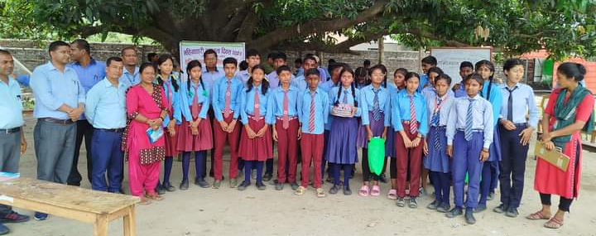
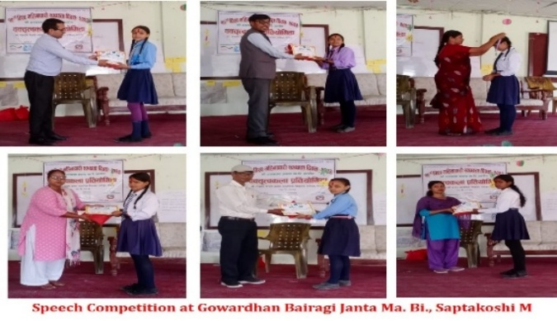
ª_ ljBfno tyf :jf:y s]Gb|df gd'gf vfg]kfgL ;'ljwf tyf ;/;kmfO ;'ljwf M
o; kl/of]hgf cGt/ut laBfnox?df :jf:y ;/;kmfOsf] Ps Jojl:yt k|0ffnLsf] ljsf; x'g'sf] ;fy} Ps p4fx/0fsf] ?kdf ;Ktsf]zL g=kf= df gu/kflnsfsf] ;xof]u ;lxtsf] ;dGjo / lg0f{odf ! laBfno ! laBfno >L ljz]Zj/ a}/fuL cfwf/e't laBfno anf{bx / :jf:y s]Gb| dn]7, sdnk'/df ;/;kmfO tyf vfg]kfgL Joj:yfkgsf] nflu k"jf{wf/df sfd ul/of] eg] cUgL;fO/ s[i0ff ;j/0f uf=kf= cGt/ut kflnsfsf] lg0f{o / ;dGjodf jf8{ g= ! l:yt 7fs'/ hL df=lj= jf8{ g= $ l:yt dlxs/ df=lj= tyf jf8{ g= @ l:yt ;'=b]=k'm= df=ljdf laBfyL{sf] cg'kftdf rflxg] zf}rfnox?, o'/Lgn nufot ;]ˆ6L 6\ofs / xft w'g] :6zg ;lxt k|ofKt vfg]kfgLsf] Joj:yf u/L Ps ;/;kmfOo'Qm gd'gf laBfnosf] ?kdf Joj:yfkgdf ;xof]u u/]sf] cj:yf 5 .
laBfnox?df o;/L vfg]kfgL, ;/;kmfO tyf :jR5tfsf] sfo{qmdn] ;Kt/L lhNnfsf] % j6f kflnsfsf] xfn ;Dd ^ j6f laBfnox? b"O tf/f laBfno 3f]if0ff ug{ ;kmn ePsf] 5 .
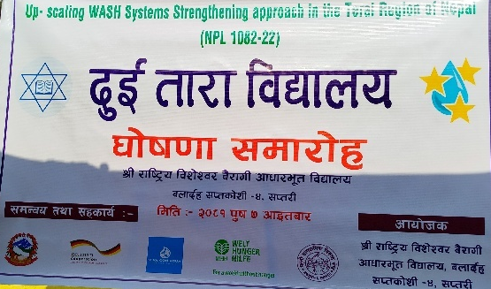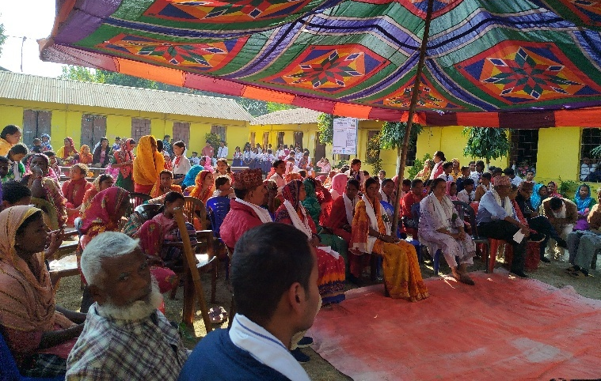
r_ ;fd'bfo :t/df vfg]kfgL kx'rsf] nflu vfg]kfgL Joj:yfkg / ;+rfng M
o; kl/of]hgf cGt/ut u|fld0f If]qdf kfgLsf] cfefjsf] cfjZoQmfnfO{ Wofgdf /fVb} cUgL;fO/ s[i0ff ;j/0f jf8{ g= @ l:yt l;tfk'/ vfg]kfgL cfof]hgfnfO{ :yfgLo ;/sf/n] lgdf{0f u/]sf] cw'/f] vfg]kfgLnfO{ k"0f{tf lbgsf] nflu lqkIfLo ;Demf}tfsf] cfwf/df sfo{ u/]sf] cj:yf 5 . t/ ;Dk"0f{ sfo{ ;DkGg eP klg kfgL ;kmf gcfpg] sf/0fn] hg;fd'bfon] z'4 vfg]kfgL vfg kfPsf 5}g\g .
To;} u/L ljKkg blnt a:tLdf kfgLsf] clt cfefjsf] cfaZoQmfnfO{ Wofgdf /fvL xfn #@ kl/jf/nfO{ nlIft u/L Ps j]x/frfk vfg]kfgL ;/;kmfO Ps ldgL of]hgfdf ;xof]u u/L /x]sf] ca:yf 5 . eljZodf %) kl/jf/ ;Ddsf] @%) hgfnfO{ kfgL k'tL{ ug{ Ifdtf /x]sf] 5 . o; kl/of]hgfsf] s'n cg'dflgt nfut ? @( nfv /x]sf] 5 eGg] hg >dbfg nueu % k|ltzt eGbf a9L /x]sf] 5 . of] Ps blntx?sf] gd'gf a:tLsf] ?kdf klxrfg x'g ;Sg] a:tLsf] ?kdf /x]sf] 5 .
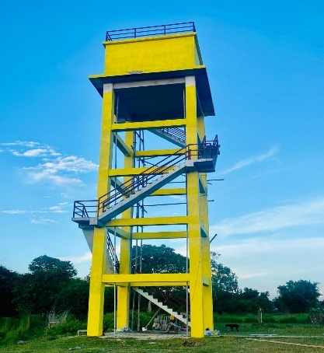
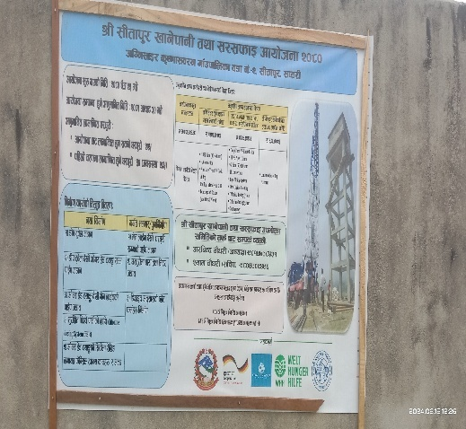
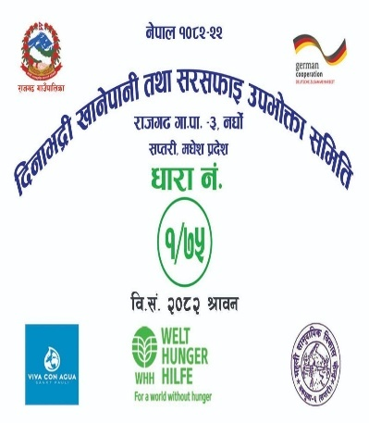
5_ ;fd'bfo c+s kq M ;fd'bfosf] nfeu|fxL tyf ;]jf k|bfos ljrsf] pt/bfloTj dfkg ug]{ / To;df ;'wf/ tyf k|a4{g ug{] Ps ljlw Æ;fd'bfo c+s kqÆ sf] yfngL ul/Psf] 5 . ;]jf k|bfossf] ;]jfsf u'0f:t/, ;fd'bfodf ePsf ljsf; sfo{x?sf] dfkg ug]{ tyf nfeu|fxLn] vf]h]sf] ;]jf / u'0f:t/ tyf ;]jf k|bfosn] ;]jf k|jfx u/]sf] ;]jf / u'0f:t/df s'g:t/ ;Ddsf] ;dfgtf /x]sf], g/x]sf] eGg] s'/fsf] dfkg ug]{ / b'j} kIfn] lgjf{x ug'{ kg]{ pt/bfloTj tyf lhDd]jf/Ldf ;'wf/ Nofpg] kIfdf ;DaGwsf] ;'dw'/tf Nofpg o; ljlwsf] k|d'v e'ldsf /x]sf] kfOPsf] 5 . h;n] sfo{ k|ultdf ;'wf/ :yfgLo pt/bfloTj tyf lhDd]jf/Lsf] af]wdf ljsf; ePsf] cg'ej /x]sf] 5 .
!@=#_ nlIft kl/0ffd -@_ :yfgLo tx :t/df M
nlIft kl/0ffd @ sf] nflu sfo{If]qsf] % j6} kflnsfdf kl/of]hgfsf] p4]Zo / nIo cg'?k kflnsf;+u cled'lvs/0f uf]i7L u/L sfo{qmdsf] ?k/]vf nufot ah]6sf] kf/blz{tf ub}{ kflnsfx?;+u Ps lsl;dsf] ;Demf}tf u/L sfo{qmdx? ;+rfng ul/of] . h;df kl/of]hgfn] ul/g] ;]jf tyf lqmofsnfkx? ;xof]u ug]{ If]qx? tyf :yfgLo txsf] e'ldsf tyf pt/bfloTj / lhDd]jf/L ;d]tsf] ;xdtLsf] cfwf/df ;Demf}tf /x]sf] 5 .
s_ sfo{qmdsf] jflif{s ;ldIff tyf kf/blz{tf M
kl/of]hgf cGt/utsf] ;+rfng ul/Psf] lqmofsnfkx? jf/]sf] k|ult o;df ePsf] vr{x? To;jf6 ;fd'bfo / hgtf ePsf pknAwLx?sf] jflif{s?kdf kflnsf cg';f/ 5'6f 5'6} ;ldIffx? ;+rfng ul/of] / hg k|ltlgwx?sf] ;Nnfx ;'emfjx? ‘+;+sng u/L hg;/f]sf/sf] lxt cg';f/sf] kl/dfh{g / lqmofsnfkx? ;+rfng ul/of] . o;n] sfo{qmddf kf/b/lz{tf , hg;/f]sf/ tyf hg k|ltlglwx?df :jfldTjsf] cfef;df a[l4 x'g'sf] ;fy} sfo{qmd ;+rfng ;+rfngdf ;xhtf ePsf] cg'ej /x]sf] 5 .
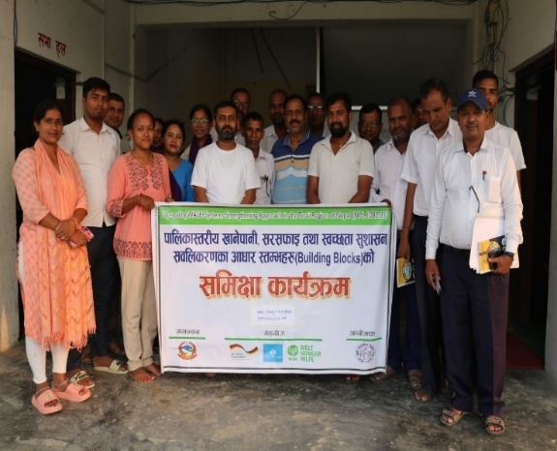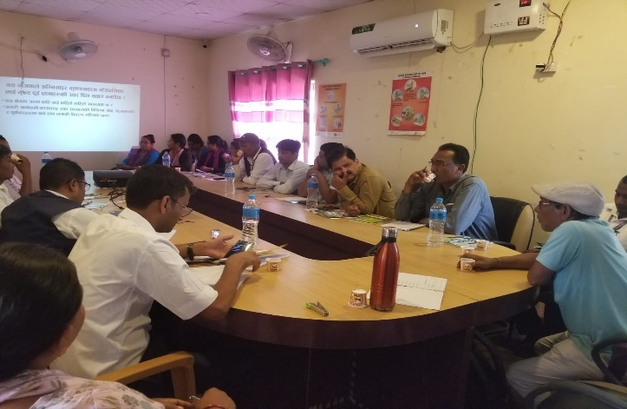
v_ cjnf]sg e|d0f tyf l;sfO tyf cg'ej cfbfg k|bfg M
:yfgLo tx kbflwsf/Lx?sf] Ifdtf clea[l4 tyf l;sfO{ lng hfGg a'emg vfg]kfgL tyf ;/;kmfO If]qdf ;kmn sfo{x?sf] cjnf]sg cWoog e|d0f sfo{qmdx? lg/Gt/ eO /xof] . h;df kflnsf kbflwsf/Lx?, vfg]kfgL of]hgfsf] pkef]Qmf ;ldltsf] kbflwsf/Lx? , laBfnosf lzIfsx? Tyf ljBfyL{x?sf] 5'6f 5'6} ?kdf ljifout ?kdf l;sfOsf] nflu cjnf]sg cWoog e|d0fx? ;DkGg ul/of] . h;df cg'ej, sfo{ r'gf}tL, sfo{ of]hgf lgltlgod , sfo{of]hgf lgdf{0f b]lv :yfgLox?sf] ;xeflutfjf6 of]hgfx? ;kmn ePsf] / o;n] vfg]kfgL , kmf]x/ Joj:yfkg , sfo{ ;+rfng k|0ffnLsf] l;sfO ePsf] / ;f] cg';f/ Ifdtfsf] cfwf/df ;Kt/Ldf klg ug{ ;lsg] cfTdljZjf;df a[l4 ePsf] b]lvof] .
qm=;= | cjnf]sg cWoog e|d0fsf] lsl;d jf gfd | cjnf]sg e|d0fsf] If]q | ;xefuL ;+Vof | s}lkmot
! | South Asia Conclave on WASH - 10-13 Sep 2024 @ Delhi | New Delhi- India | @–k|d'v tyf pk k|d'v – ;Ktsf]zL gu/kflnsf
@ | Nepal Sanitation Tour 2025 | g]kfnsf d'Vo d'Vo vf=:j=;= sf If]qx? | !–k|d'v ;Ktsf]zL gu/kflnsf
# | Learning Sharing Visit | Model Drinking Water Supply Scheme-Madi, Ratananagr, Chitwan | % j6} :yfgLo txsf] %–% hgf hgf k|tL lgwL tyf sd{rf/Lx?
$ | Exposure Visit | Board Model and Sanitary napkin Entrepreneur- Sarlahi, Chitwan and Dhading | @–j8f cWoIf cUgL;fO/ s[i0ff ;j/0f uf=kf= /vf=:j=;= Focal Person-;Ktsf]zL gu/kflnsf

u_ k|fljlws ;xof]u tyf ;dGjofTds ;xof]u M o; kl/of]hgf leq tkl;nsf lgDg sfo{x?df kl/of]hgfjf6 k|fljlws tyf k/fdz{ ;xof]u u/sf 5g\ .
!_ vfg]kfgL ;/;kmfO tyf :jR5tf of]hgf lgdf{0f sfo{df M
o; kl/of]hgfsf] p4]Zo cg'?k :yfgLo txdf vfg]kfgL ;/;kmfO tyf :jR5tf ;DalGw Ps Jojl:yt cfalws of]hgf xf];\ / To; cg'?k :yfgLo txn] aflif{s?kdf >f]t Joj:yfkg , cGo ;+3 ;+:yf;+u ;dGjo u/L Ps kl5 Ps u/L ;Da4 tfl/sfn] ;j} 3/ w'/Ldf z'4 vfg]kfgLsf] kx'r ug{ tyf 6f]n ;fd'bfodf ;/;kmfOsf] cfwf/e't ;+/rgfx? eO{ :jR5 ;fkmf kflnsf lgdf{0f ug{ of] vfg]kfgL ;/;kmfO tyf :jR5tf of]hgfsf] k|d'v e'ldsf /xg] 5 . h;df o; kl/of]hgfn] ;fd'bfo b]lv xf6 jfhf/, rf}s rf}/fxf nufot zf}rfnosf] cfjZoQmf / vfg]kfgLsf] kx'rsf] cfwf/ agfP/ aflif{s a[l4 x'g] hg;Vof ;d]tnfO{ dWo gh/ ub}{ sfo{If]q leqsf] % j6} kflnsfdf !) jif]{ vfg]kfgL ;/;kmfO tyf :jR5tf of]hgf lgdf{0fdf ;xof]u u/L of]hgf lgdf{0f ePsf] 5 .
-@_ P]g / sfo{ljlw lgdf{0fdf M
o; kl/of]hgfn] ;d]6LPsf % j6} kflnsfsf] NWASH MIS df cfwfl/t !) jif{] vf=:j=;= of]hgf nfO{ sfo{Gjogdf n\ofpgsf] lgldt cfjzos kg{] vf=:j=;= P]g nufot, kflnsf :t/df ;+rflnt vfg]kfgL kl/If0f k|of]uzfnf ;+rfngsf] nfuL rflxg] sfo{ljlw h:tf dxTjk"0f{ gLlt lgod lgd{f0fdf ;d]t kl/of]hgfn] k|fljlws tyf k/fdz{ ;xof]u /x]sf] 5 .
v_ vfg]kfgL, ;/;kmfO tyf :jR5tf k|0ffnLsf cfwf/ :tDex¿sf] ;ldIff M
cw{jflif{s ?kdf % j6} :yfgLo txsf] vf=:j=;= k|0ffnLsf cfwf/ :tDex¿sf] ;ldIff ul/+b} ;'wf/ ug{ kg{] If]qx¿sf] klxrfg ul/ plrt sfo{ of]hgf agfpb} ;f] lx cg'¿ksf] ;'wf/fTds k|of;x¿ eO/x]sf] cj:yf 5 . vf=:j=;= ;DjGwL gLlt tyf sfg'gx¿sf] lgd{f0f, ah]6 lalgof]hg, Ifdtf clelj|bL, ;'k/Lj]If0f h:tf s'/fx¿sf] pn\n]vgLo k|ult ePsf] k|df0f b]vg ;lsG5 .

!@=$ _ nlIft kl/0ffd -#_ k|b]lzs :t/df M
k|df0fdf cfwfl/t kl/of]hgfsf] k4lt, pks/0f / l;sfO{, k}/jL / 1fg cfbfgk|bfg dfkm{t k|b]z / ;+3Lo :t/df k|j4{g ug{' /x]sf] 5 .
Vffg]kfgL ;/;kmfO tyf :jR5tf ;DalGw l;sfO cfbfg k|bfg sfof{zfnf uf]i7L M o; k|ltj]bg jif{df dw]z k|b]z hgsk'/df ;DalGwt & j6f dGqfnox?sf] ;+o'Qm pkl:yltdf k|b]z :t/Lo Vffg]kfgL ;/;kmfO tyf :jR5tf ;DalGw l;sfO cfbfg k|bfg sfof{zfnf uf]i7Lsf] cfof]hgf u/LPsf] lyof] . To;df l;/xf / ;Kt/Lsf !) j6f kflnsfsf kbflwsf/L tyf hg k|ltlglwx?, ;/f]sf/jnfnf lgsfosf k|ltlglwx? ;fem]bf/ ljsf;] ;+:yfsf k|ltlglwx? tyf k|qsf/x? ljr Ps cfkmgf] cfkmgf] sfo{If]qdf vfg]kfgL ;/;kmfO tyf :jR5tfsf] If]qdf sfo{ k|ultx?, sfo{ ubf{ ef]u]sf s7LgfO{x? tyf lhNnfdf vfg]kfgL tyf ;/;kmfOsf lbuf]kgfsf] nflu ;'wf/ ug'{ kg]{ kIfx? Pj ;/sf/sf] tkm{jf6 v]Ng' kg]{ e'ldsfx? Jff/] l;sfO cfbfg k|bfg eof] .
!#_ kl/of]hgf ;+rfng ubf{ ef]u]sf ;d:ofx? r'gf}tLx? tyf l;sfO{x? / ;fdfwfgsf kxnx?
;'rs | ;'/lIft cfjf; kl/of]hgf -Xoflj6\of6 g]kfn_ | vfg]kfgL ;/;kmfO tyf :jR5tf kl/of]hgf (WHH )
/fd|f tyf ;jn kIf | g]kfn Ps ljsfzf]Gd'v b]zdf !% k|ltzt eGbf a9L k|ltzt hg;+Vof cf]U6]sf] kl/jf/x? e'ldlxg , cfjf; ljlxg tyf ;'/lIft cfjf; lgdf{0f ug{ Ifdtf gePsf] kl/jf/x?nfO{ nlIft u/L hnafo' d}qL :yfgLo >f]t ;fwgsf] k|of]ujf6 ;'/lIft cfjf;sf] cfjwf/0ff Nofpg' / Ps cfo >f]t Go'g ePsf] kl/jf/x?nfO{ ;xof]u ug'{ cfkm}df ;/xgLo /x]sf] 5 . | :jf:y g} wg xf] eGg] d'n efjgfsf] ;fy vfg]kfgL ;/;kmfO tyf :jR5tf sfo{qmd k|ToIf :jf:y;+u ;DalGwt ePsf]n] ;/;kmfOsf] cfefj / z'4 vfg]kfgLsf] sf/0fn] ljleGg k|sf/sf] /f]u Joflw nfUg] / ;Eotfdf klg k|ZglrGx x'g] ePsf]n] dfgj hLjgsf] nflu klxnf] k|fyldStfdf kg]{ ePsf] x'bfF of] ljsfzf]Gd'v b]zdf vfg]kfgL ;/;kmfO tyf :jR5tf ;DalGw hgr]tgf hufpg' lbuf] ljsf;sf] nflu of]hgfx? lgdf{0f x'g' ckl/xfo{ /x]sf]n] nlIft If]qx?df ;xof]u ug'{ of] kl/of]hgfsf] ;jeGbf ;jn kIf xf] . o; kl/of]hgfsf] sf/0fn] ! nfv ^% xhf/ hg;Vofdf ;/;kmfO tyf vfg]kfgLsf] dxTjsf] jf/]df hfgsf/L tyf ;r]tgf ePsf] 5 .
s _ r'gftLx? | !_ kl/of]hgf lgdf{0f;+u ;DalGwt x'g] t/ To; cg';f/ kl/of]hgfsf] ;doflAw gx'g] x'bfF kl/of]hgf ;DkGgtfdf k|Zg lrGx nfUg] .  @_ e'ldxlgx?nfO{ hUuf Joj:yfkg ug'{ kg]{ / :yfgLo txdf xfn e'dL Joj:yfkg ;DalGw s'g} P]g lgod sfo{ljlw gePsf]n] e'dL Joj:yfkgdf ;d:of x'g] / cfjf; lgdf{0f sfo{ ;dodf z'? klg gx'g] ;dodf ;DkGg gx'g] .  #_ of] kl/of]hgfdf :yfgLo ;/sf/sf] nufgL ;d]t x'g] xF'bf sfo{ pwf/f]df sfd ug'{ kg]{ x'bf ;dodf ;DkGg gx'g] .  $_ kl/of]hgfsf] df]8fln6L kl/of]hgfsf] k|slt cg';f/ gldn]sf]n] ;d:ofx? yk ePsf] cgej /x]sf] 5 . | lgdf{0f sfo{df s]xL ;d:ofx? b]lvg] .  /fhg}lts cl:y/tf .
!$_ lgisif{ M o; ljsf; s]Gb|4f/f ;+rflnt ;'/lIft cfjf; / vfg]kfgL ;/;kmfO tyf :jR5tf kl/of]hgf ;Kt/L lhNnfsf] nlIft u|fld0f ;fd'bfosf] nflu Ps abf{g ;fljt ePsf] 5 . kl/of]hgfsf] p4]Zo cg'?k tf]lsPsf] nlIft kflnsfx?sf] nlIft ;fd'bfOnfO{ nlIft u/L clt ljkGg , k5f8L kf/LPsf cfjZoQmfsf] cfwf/df 5gf}6 ;fd'bfodf ;]jf k'u]sf] 5 . cfjf; ljlxg kl/jf/x?n] vfg]kfgL ;/;kmfO ;lxtsf] Ps ;'/lIft cfjf;sf] cg'e'tL kfPsf] 5 eGg] :yfgLo zLkfn'x?nfO{ :j /f]huf/sf] klg cj;/ k|bfg ePsf] 5 . g]kfn Ps ljsfzf]Gd'v b]z ePsf]n] oxfFsf] k|lt JolQm cfDbfgLsf] l;df eGbf sd cfDbfgL ePsfx?n] z'4 vfg]kfgL, zf}rfnodf zf}r ug]{ tyf Ps ;'/lIft cfjf; d'gL cfkmgf] jfnaRrfx?nfO{ /fVg] / kfNg] eGg] s'/f pgLx?sf] ;f]r eGbf w]/} 6f9f /x]sf] lyP eGg] Tof] ;kgf k'/f ePsf] hg ;fd'bfosf] hgljZjf; ljsf; ePsf] 5 .
To;} u/L kflnsf:t/df klg e'ldlxg hgtfsf] nflu e'ld JoJ;yfkg ;xhLs/0f ePsf] vfg]kfgL ;/;kmfO ;DalGw ljleGg k|sf/sf] cjwf/0ff d'ns sfo{qmdsf] ;fy} cfjZos lglt lgod sfo{ ljlwx? lgdf{0fdf ;xof]u k'u]sf] 5 eGg] sltkodf z+zf]wg kl/dfh{g u/L sfof{Gjogdf ;xhtf ePsf] 5 . To;} u/L nfvf} s/f}8f} nfUg] cfjf; tyf vfg]kfgL ;/;kmfO Joj:yfkgsf] k"jf{wf/ lgdf{0fdf ;xof]u ePsf]n] kflnsfsf] c+s :t/ a9]sf] ljZjf; 5 .
cGtdf oL b'j} kl/of]hgfsf] lqmofsnfkjf6 hg;fd'bfox? v'zL ePsf5g\ / hg ;fd'bfo / hg;/f]sf/df o; ljsf; s]Gb|sf] 5jL tyf d'No / dfGotf /x]sf] 5.
!%_ cfef/ M
cGtdf o; ljsf; s]Gb|nfO{ oxfF ;Dd k'?ofpg k|ToIf ck|ToIf ;xof]u ug'{ x'g] ;Dk"0f{ dxfg'efjx?nfO{ o; ljsf; s]Gb|sf] tkm{jf6 xflb{s cfef/ k|s6 ub{5' . To;} u/L o; ljsf; s]Gb|nfO{ ;Nnfx ;'emfj ;lxt dfu{ bz{g ug'{ x'g] ;/f]sf/jfnfx?, ;fem]bf/ tyf ;xof]uL ;+:yfx? ;xof]uL lgsfox? , :yfgLo tx tyf :yfgLo txsf hg k|ltlglwx?, kbflwsf/L , ;fdflhs ;+hfnsf] dfWodjf6 xf};nf a9fO{ lbg] k|rf/ k|;f/ ug{ cd'No of]ubfg lbg] k|qsf/ aGw'x? nufot cd'No ;Nnfx ;'emfj ug]{ ;Nnfxsf/ tyf sfo{ ;ldltsf] kbflwsf/Lx?, sfo{qmdnfO{ ;kmn kfg{ lbg /ft sfo{ ug]{ ;fdflhs ;]jfsf sd{rf/Lx?nfO{ d xflb{s wGojfb 1fkg ug{ rfxG5' . o; s]Gb|nfO{ b]z ljb]zdf lrgfpg ;kmn kfg'{ ePsf] hg;fd'bfo k|lt o; s]Gb|sf] tkm{jf6 ljz]if?kdf cfef/ k|s6 ug{ rfxG5' .
k|e' gf/fo0f rf}w/L
sfo{sf/L ;lrj tyf lgb]{zs

Organizational Structure
Organogram
General Assembly (GA)
Executive Board
Executive secretary / Director Sub Committees
Management Committee. Recruitment committee
Assistant Director Procurement committee
Monitoring committee
Working Department Disposal Committee
Physical Assets audit committee
Program operation Admin & Finance .

Project Coordinators Admin & finance Officer-

Thematic officers Accountant / Logistice

Technicians store Keeper

Assistant offcicer Office Assitant

Social mobilizer Security / Driver
Local Resource persons Cleaner

sd{rf/Lx?sf] sfo{ ljj/0f tyf lhDd]jf/L M
qm=;= | sd{rf/Lsf] gfd | kb | lhDd]jf/L | sfo{If]q uf=lj=;= | s}lkmot
! | >L k|e' gf/fo0f rf}w/L | sfo{sf/L k|d'v | ;j} | ;+:yfsf] sfo{If]q
@ | >L rGb| gf/fo0f rf}w/L | ;xfos lgb]{zs | Xoflj6\of6 g]kfnsf] ;xof]udf ;+rflnt sfo{qmdsf] ;+of]hs eP/ ;+rfng ug]{ . | zDe'gfy g=kf= ;Ktsf]zL g=kf= / cUgL;fO/ s[i0ff ;j/0f uf=kf=
# | >L k|tfk >]i7 | kl/of]hgf ;+of]hs | WHH sf] ;fem]bf/Ldf ;+rflnt vfg]kfgL tyf ;/;kmfO :jR5tf sfo{qmd ;+rfng . | 8fSg]Zj/L= ;Ktsf]zL g=kf=tyf cUgL;fO/ s[i0ff ;j/0f, lji0f'k'/ / /fhu9 uf=kf=
$ | >L ;'lgtf s'df/L rf}w/L | k|= tyf ljQ clws[t | ;+:yfut tyf Xoflj6\of6 jf6 ;+rflnt sfo{qmdsf] | ;j}
% | >L ;Gtf]if s'df/ rf}w/L | jf; clkm;/ | WHH sf] ;fem]bf/Ldf ;+rflnt vfg]kfgL tyf ;/;kmfO :jR5tf sfo{qmd ;+rfng . | 8fSg]Zj/L= ;Ktsf]zL g=kf=tyf cUgL;fO/ s[i0ff ;j/0f, lji0f'k'/ / /fhu9 uf=kf=
^ | >L dw'dfof s6jfn | ljt clws[t | WHH sf] ;fem]bf/Ldf ;+rflnt vfg]kfgL tyf ;/;kmfO :jR5tf sfo{qmd ;+rfng . | ;DalGwt kl/of]hgf If]qsf]
& | >L /fh' clwsf/L | kflnsf ;+of]hs | WHH sf] ;fem]bf/Ldf ;+rflnt vfg]kfgL tyf ;/;kmfO :jR5tf sfo{qmd ;+rfng . | ;DalGwt kl/of]hgf If]qsf]
* | >L k|ldnf rf}w/L | kflnsf ;+of]hs | WHH sf] ;fem]bf/Ldf ;+rflnt vfg]kfgL tyf ;/;kmfO :jR5tf sfo{qmd ;+rfng . | ;DalGwt kl/of]hgf If]qsf]
( | >L lha5 ;flkm | kflnsf ;+of]hs | WHH sf] ;fem]bf/Ldf ;+rflnt vfg]kfgL tyf ;/;kmfO :jR5tf sfo{qmd ;+rfng . | ;DalGwt kl/of]hgf If]qsf]
!) | >L cf]d k|sfz k08Lt | k|fljlws | WHH sf] ;fem]bf/Ldf ;+rflnt vfg]kfgL tyf ;/;kmfO :jR5tf sfo{qmd ;+rfng . | ;DalGwt kl/of]hgf If]qsf]
!! | >L tf/fsfGt rf}w/L | ;j OghLgLo/ | Xoflj6\of6 jf6 ;+rflnt sfo{qmdsf]
!@ | >L cfgGb s'df/ efifdf | ;j OghLgLo/ | Xoflj6\of6 jf6 ;+rflnt sfo{qmdsf]
!# | >L lx/f s'df/L rf}w/L | ;fdflhs kl/rfns | ;+:yfut tyf Xoflj6\of6 jf6 ;+rflnt sfo{qmdsf]
!$ | uLtf rf}w/L | ;fdflhs kl/rfns | ;+:yfut tyf Xoflj6\of6 jf6 ;+rflnt sfo{qmdsf]
!% | >L cg'hf s'df/L rf}w/L | ;fdflhs kl/rfns | WHH sf] ;fem]bf/Ldf ;+rflnt vfg]kfgL tyf ;/;kmfO :jR5tf sfo{qmd ;+rfng .
!^ | >L OGb|snf rf}w/L | ;fdflhs kl/rfns
!& | >L l;tf nfdL5fg] | ;fdflhs kl/rfns
!* | >L sNkgf ofbj | ;fdflhs kl/rfns
!( | >L z'l;n s'df/ ;fx | ;fdflhs kl/rfns
@) | >L /fhb]j kf;dfg | ;fdflhs kl/rfns
@! | >L /fd s'df/ d'lvof | ;fdflhs kl/rfns
@@ | >L k|d]z s'df/ rf}w/L | sfof{no ;xof]uL
cg';'rL $
o; dx'nL ;fd'bflos ljsf; s]Gb|sf] Pltxfl;s ljj/0f M
!_ cf=j= @)$* ;fndf cgf}krfl/s ;+u7gsf] u7g tyf tTsflng asw'jf uf=lj=;= – ^ klZrdjf/L 6f]nsf] jf6f] 3f6f] lj:tf/ tyf ;/;kmfO{ sfo{qmdjf6 z'ef/De eof] .
@_ cf=j= @)$( ;fndf b]p;L v]nsf] z'?jft u/L / ;+slnt /sdjf6 ufFp ljsf; o'jf kl/rfngdf nufgL .
#_ cf=j= @)%) ;fndf 5]p 5fpsf] PnfgL ktL{df ;fd'lxs wfgv]tL u/L !& dg wfg pAhgL u/L sf]ifsf] Aoj:yf u/]sf] .
$_ cf=j= @)%) ;fndf cf}krfl/s ;+u7gsf] cjwf/0ff / tby{ ;ldlt u7g / k|ult zLn o'jf Snjsf] gfdjf6 ljwfg lgdf{0f / lh=k|=sf= ;Kt/Ldf btf{sf] nflu k]z . sf/0fjz of] gfdn] Snjsf] btf{ x'g g;s]sf]n] dx'nL o'jf Snjsf] gfdjf6 ldlt @)%! ;fn h]i6 #) ut] ;+:yf btf{ P]g @)#$ cGt/ut ljlwjt btf{ eO{ ;+:yf :yfkgf ePsf] xf] .
%_ ldlt @)%@ ;fn c;f]h $ ut] ;dfh sNof0f k/Lifbdf cfa4 ePsf] .
^_ cf=j= @)%@ / )%# df cgf}krfl/s lzIff af]8{sf] ;xof]udf cgf}krfl/s lZfIff sfo{qmd- $ ±( Ö!# _ uf=lj=;= df - jfn tyf k|f}9 lzIff ;kmntf;fy ;+rfng _
&_ asw'jf uf=lj=;=sf] ;xof]udf vfg]kfgL tyf ;/;kmfO sfo{qmd ;+rfng .
*_ bft[ ;+:yf ;+:yfx?n] dx'nL o'jf Snj v]n s'b ug]{ ;+:yf eg]/ jf:tf gug]{ / @)%^ ;fndf ;+:yfsf] gfd k/Ljt{g eO{ dx'nL ;fd'bflos ljsf; s]Gb| ePsf] .
(_ k|f}9 lzIffjf6 n3'ljtsf] k|]/0ff kfPsf] / @)%$ ;fnjf6 cgf}krfl/s ?kjf6 ;d'x art tyf C0f sfo{qmd z'? ePsf] / o; ;d'x art tyf C0f sfo{qmdsf] kxnf] C0fL ;b:o uf=lj=;= asw'jf ^ j:g] ;'Gb/ nfn rf}w/Lsf] >L dlt cl;of b]jL rf}w/L /x]sL / klxnf] C0f ? @))) .– dfq k|jfx ePsf] lyof] df3 dlxgf ^ ut] .
!)_ cf=j= @)%$÷ )%% df dlxnf n3' C0f kl/of]hgfdf k|:tfj k]z / @)%% jf6 @)%& ;Dd sfo{qmd ;+rfng tyf @)%* ;+:yfsf] Ifdtf ljsf; ;DalGw tflndx? k|fKt .
!!_ @)%^ ;fndf g]kfn /fi6« a}ssf] 8Lk'6L 8fO/]s6/ ch'{g jfj' ltjf/Ljf6 ljQLo dWo:ytf ;DalGw k|]/0ff tyf hfgsf/L / lgj]bg btf{ .
!@_ @)%& ;fn h]i6 #) ut] ;Kt/L lhNnfsf] $ uf=lj=;= sfo{If]q ;lxtsf] ljQLo dWo:ytfsf] k|df0f kq k|fKt ePsf] . >fj0f ! ut] jf6 n3'ljt sfo{qmd cf}krfl/s ?kjf6 z'? ePsf] .
!#_ ;fd'bflos ;d'x l;rfO{ ;xof]u sfo{qmd - CGISP_ l;rfO ljefu nxfgsf] ;xof]udf .
!$_ cf=j= @)%&÷)%* df sfdsf] nflu vfBfg - FFW _ Gtz) sf] ;xof]udf.
!%_ cf=j= @)%*÷)%( / )%(÷)^)df sfdsf] Plss[t vfB ;xof]u -IFSP_Gtz) sf] ;xof]udf.
!^_ cf=j= @)^)÷)^!÷^@ df sfdsf] u|fld0f ;fd'bfo k"jf{wf/ sfo[qmd -RCIW _ Gtz) sf] ;xof]udf.
!&_ c= cf=j= @)^@÷)^#÷^% df sfdsf] u|fld0f sfo{qmd g]kfn -RPN _ Gtz) sf] ;xof]udf.
!*_ cf=j= cf=j= @)%(÷)^) b]lv @)^$÷)^% ;Ddf ljs]Gb|Ls[t :yfgLo zf;g ;xof]u sfo{qmd (DLGSP_ lh=lj=;= :yfgL ljsf; dGqfno .
!(_ cf=j=@)^@÷)^# df NGO /CBO) project. Support Pact Nepal.
@)_ cf=j=@)^$ df sf]zL t6aGw lkl8t ;xof]u sfo{qmd,;xof]u M sg;{g g]kfn ( WFP _
@! _ cf=j= @)^%÷)^^ df o'jf ;fdflhs hjfkm b]xfoLtf tyf k/Lrfg sfo{qmd US AId sf] ;xof]udf .
@@_ cf=j= @)^^÷)^& df DED jf6 ;+:yfut ljsf; ;xof]udf cfod'ns tyf lzkd'ns lqmofsnfkdf ;xof]u .
@#_ cf=j= @)^^ df lj/f6 gl;{Ë xf]dsf] k|fljlws ;xof]udf kf7]3/ tyf ufOgf] nufot h]g]/n lkmhLl;og ;DaGwL :jf:y lzlj/ ;+rfng .
@$= cf=j= @)^^÷@)^& df Quipsy :yfgLo ljsf; sf]ifsf] ;xof]udf ;+rfng /xof] .
@%_ cf=j= cf=j= @)^^÷)^& b]lv @)&) ;fn cfiff9 ;Dd LGCDP lh=lj=;= ;Kt/L ;xof]udf .
@^_ cf=j= @)^^÷)^& jf6 @)&!÷@)&@ ;Dd $ uf=lj=;=df u/LjL lgjf0f sfo{qmd ;+rfng .
@&_ cf=j= @)^^÷@)^& jf6 @)^* ÷@)^( EAFSP ( Enhance access financial support program) g]kfn /fi6 a}+s / UNDP/ UNCDF @ jif{sf] nflu .
@*_ cf=j= @)^^÷@)^& df JFER s[lif If]qdf ;xof]usf] nflu lhNnf ljsf; jf6 .
@(_ cf=j= @)^^÷@)^& df Habtat for humanity Nepal ;+usf] ;xof]udf ;Kt/L, l;/xf / pbodf k|lt jif{ lgdf{0f x'g] gofF 3/sf] tYofFs tyf ;j]{If0f / tyf hgr]tgf ljsf; sfo{qmd .
#)_ cf=j= @)^&÷@)^* jf6– Habtat for humanity Nepal ;+usf] ;fe]mbf/Ldf cy{k'0f{ hLjgsf] nflu cfjf; sfo{qmd ;+rfng .
#!_ cf=j= @)^*÷@)^( jf6 :jf:y ;/;kmfO{sf] lzIff tyf hgr]tgf ljsf; sfo{qmd / ls6 tyf lzIff ;fdu|L ljt/0f - Korea International Cooperation Agency _ Koica Project .
#@_ cf=j= cf=j= @)^*÷)^( jf6 u|fld0f vfg] kfgL tyf ;/;kmfO{ ljsf; sf]if sfo{qmd # j6f uf=lj=;= df ;+rfng / ;DkGg .
##_ cf=j= @)^*÷@)^( df ljZj a}+ssf] ;xof]udf ;];L;+usf] ;fem]bf/L ;fdflhs hjfkm b]xfoLtf k|fg ! sfo{qmd .
#$_ cf=j= @)^(÷@)&) df - Korea International Cooperation Agency _sf] ;xof]udf cu'jf dlxnfx?sf] Ifdtf clea[l4 sfo{qmd - Female Headed Project _ .
#%_ ldlt @)&)÷@÷#) df dx'nL ;fd'bflos n3'ljQ ljQLo ;+:yf ln=sf] k|a4{g / #÷! ut] b]lv zfvf x:tfGt/0f sfo{ k|f/De eO{ ebf};Dddf x:tfGtl/t .
#^_ cf=j= @)&)÷@)&! Dff /fi6«Lo u'? of]hgf @)^* cGt{ut g]kfnnfO{ @)!& ;Dddf v'Nnf lbzf d'Qm If]q 3fif0ff ug]{ d'n p4]Zosf] nIo xfl;n ug{ lhNnf vfg]kfg] ;/;kmfO{ l8lehg sfof{no ;Kt/Lsf] ;xof]udf k'; !& ut]sf] ;demf}tf cg'?k ;Kt/L lhNnfsf] !) j6f uf=lj=;=df ;/;kmfO{ ;DalGw hgr]tgf sfo{qmd ;+rfng .
#&_ /fi6«Lo u'? of]hgf @)^* cGt{ut @)!& ;Dddf g]kfnnfO{ / ;g @)!^ cfufj} ;Kt/L lhNnfnfO{ v'Nnf lbzf d'Qm 3f]if0ff ug]{ nIo k'/f ug{ o'lg;]km g]kfnsf] ;xof]udf ldlt @)&!÷&÷!* ut]jf6 ;g @)!% h'g leq cyf{t @)&@ cfiff9 d;fGt;Dd ;Kt/Lsf] @ j6f uf=lj=;=df k"0f{ ;/;kmfO{ cGt/ut v'Nnf lb;f d'Qm sfo{qmd ;+rfng / ;do leq ;DkGg .
#*_ To;}u/L ;Kt/L lhNnfnfO{ v'Nnf lbzf d'Qm 3f]if0ff ug]{ nIo k'/f ug{ o'lg;]km g]kfnsf] ;xof]udf ldlt @)&@÷>fj0f÷! ut]jf6 ;g @)!^ h'g leq cyf{t @)&# cfiff9 d;fGt;Dd ;Kt/Lsf] @ j6f g=kf= ;Ktsf]zL / s~rg?kdf k"0f{ ;/;kmfO{ cGt/ut v'Nnf lb;f d'Qm sfo{qmd clofg ;+rfng / tf]lPsf] ;do leq v'nf lbzf If]q 3f]if0ff ;DkGg .
#(_ ldlt @)&! ;fn df3jf6 tbg';f/ km]a|'c/L @)!%—@)!& ;Dd ;Kt/Lsf] $ uf=lj=;=df x]Ne]tf; / Ol;df]8sf] ;fem]bf/L ;xof]udf hnpkof]u u'? of]hgf sfo{qmd .
$)_ @)&! ;fndf lj/f6 gl;{Ë xf]d, dx'nL d]8Lsn tyf MCDC sf] sf]/km08jf6 h]g]/n :jf:y ;DalGw PS;/] ;xoftf ;d]tsf] lzlj/ ;+rfng / &)) lj/fdLx?sf] lgz'Ns pkrf/ sfo{qmd ;+rfng .
$!_ ;Kt/L lhNnfnfO{ k"0f{ ;/;kmfOdf ;xof]u ug{sf] nflu KOICA sf] ;xof]udf @)&@ ;fn a}zfvdf # dlxgfsf] nflu Grant Funded Project ;kmntf;fy ;+rfng .
$@_ cf=j= @)&@÷@)&# df yk # uf=lj=;= ;lxtsf] & j6f uf=lj=;= df u/LjL lgjf/0f sfo{qmdsf] bf]]>f] ;Demf}tf ;DkGg / @)&$ ;Dd sfoqmd ;+rfng .
$#_ cf=j= @)&@÷ @)&# df ljkb Joj:yfkgsf] nflu Responsible Disaster sustainable project ;Kt/Lsf] /fdk'/f dNxlgof cfunflu If]qsf] Joj:yfkgsf] nflu Habitat for Humanity Neapl sf] ;xof]u .
$$_ cf=j= @)&@÷ @)&# df ljkb Joj:yfkgsf] nflu Building Disaster Resilent project ;Kt/Lsf] ljleGg uf=lj=;= tyf g=kf=sf] nflu ;+rfng Habitat for Humanity Neapl sf] ;xof]u .
$%_ cf=j= @)&@÷ @)&# df ljkb Joj:yfkgsf] nflu Bamboo Cultivation and promotion Project ;Kt/Lsf] ljleGg uf=lj=;= tyf g=kf=sf] nflu ;+rfng Habitat for Humanity Neapl sf] ;xosfo{df Neatherland sf] ;xof]u /x]sf] 5 .
$^ _ cf=j= @)&#÷ @)&$ df ;fd'bfo ;'b[l9s/0fsf] nflu SAMSUNG Project ;Kt/Lsf] ljleGg uf=lj=;= tyf g=kf=sf] nflu ;+rfng Habitat for Humanity Neapl sf] ;xosfo{df Neatherland sf] ;xof]u /x]sf] 5 .
$& _ cf=j= @)&#÷ @)&$ jf6 ;fd'bfo ;'b[l9s/0fsf] nflu MET LIFE Project ;Kt/Lsf] ljleGg uf=lj=;= tyf g=kf=sf] nflu ;+rfng Habitat for Humanity Neapl sf] ;xosfo{df ] ;xof]u /x]sf] 5 .
$*_ cf=j @)&$÷@)&% df :yfgLo cfjf; >f]t ;fwg ljsf;sf] nflu Bamboo Cultivation and promotion Project ;Kt/Lsf] ljleGg uf=lj=;= tyf g=kf=sf] nflu ;+rfng Habitat for Humanity Neapl sf] ;xosfo{df Neatherland sf] ;xof]u /x]sf] 5 .
$(_ cf=j @)&$÷@)&% jf6 @)&%÷@)&^ ;Dd :yfgLo ;fd'bfosf] ljsf; u/L ljkb Joj:yfkgsf] cjwf/0f lnP/ CHHANA Project ;Kt/Lsf] cUgL ;fO/ uf=kf= sf]] Habitat for Humanity Neapl sf] ;fem]bf/Ldf Australian sf] ;xof]u /x]sf] 5 .
%)_ cf=j @)&$÷@)&% df lzt nx/sf] ;d:ofjf6 lkl8t a:tLsf] nflu ;fwf/0f cfjf; Joj:yfkgsf] nflu Joy Fondation Nepal sf] ;xof]udf cfjf; lgdf{0f sfo{qmd .
%!_ cf=j @)&$÷@)&% df blnt kl/jf/sf] jfnjflnsfsf] nflu PA Nepal sf] ;xof]udf jfn ljsf; s]Gb| lgdf{0f sfo{qmd .
%@_ cf=j @)&$÷@)&% df dx'nL n3'ljt / cfkmgf] sf]/ km08jf6 c=s=;= % sf] ;8sv08df Ps cf/ ;L ;L sne6{ lgdf{0f sfo{ ;DkGg .
%#_ cf=j @)&%÷@)&^ of]Ë ln8/ ljN8;\ , o'jf g]t[Tj ljsf; . Habitat for Humanity Neapl sf] ;fem]bf/Ldf CCL sf] ;xof]u .
%$_ cf=j @)&%÷@)&^ ;:tf], lbuf], k|sf]k k|lt/f]ws cfjf; lgdf{0f ;xof]u4f/f dlxnf zzlQms/0f sfo{qmd Habitat for Humanity Neapl sf] ;fem]bf/Ldf Arubian Gulf fund sf] ;xof]u .
%%_ cf=j @)&%÷@)&^ b]lv @)&(÷@)*) ;Dd cyf{t @)!( b]lv @)@# cyf{t km]a|'/L ;Dd WHH sf] ;fem]bf/L ;xof]udf WASH Governance (NPL- 1060- 19) ;kmntf ;fy ;+rfng .
%^_ cf=j @)&%÷@)&^ df SNV Nepal sf] ;xof]u / ;fem]bf/Ldf v8u g=kf= df ;fj{hlgs zf}rfno tyf 6]«Gr lgdf{0f sfo{ ;kmntf ;fy ;DkGg .
%&_ cf=j @)&^÷@)&& df WINE to WATER Nepal sf] ;xof]udf Covide 19, Corona reponse df ;xof]u tyf sfo{qmd ;kmntf;fy ;+rfng .
%*_ cf=j @)&^÷@)&& df CHHANA Project t];|f] km]h Habitat for Humanity Neapl sf] ;fem]bf/Ldf zDe'gfy / cUgL;fO/ s[i0ff ;j/0fdf .
%(_ cf=j @)&&÷@)&* df CHHANA Project zDe'gfy Habitat for Humanity Neapl sf] ;fem]bf/Ldf km]h zDe'gfy / cUgL;fO/ s[i0ff ;j/0fdf .
^)_ cf=j @)&&÷@)&* df n3'ljt ;+:yf / o; ljsf;s]Gb|sf] ;fem]bf/Ldf ;Kt/L lhNnfsf] lji0'k'/ uf=kf=sf] ?b|gf/fo0f df=lj=df vfg]kfgL tyf ;/;kmfO ;'ljwf sfo{qmd ;+rfng .
^!_ cf=j @)&*÷@)&( df CHHANA Project zDe'gfy Habitat for Humanity Neapl sf] ;fem]bf/Ldf ;fpy ;fGtf j/j/f / lxN6L kmfpg8]zgsf] ;xof]udf zDe'gfy / cUgL;fO/ s[i0ff ;j/0fdf cfjf; lgdf{0f .
^@_ cf=j @)&(÷@)*) cyf{t @)@# b]lv xfn;Dd WHH sf] ;fem]bf/L ;xof]udf vfg]kfgL ;/;kmfO{sf] nflu % j6f kflnsfdf WASH System Strengthening approach in the Terai (NPL- 1082- 22) ;kmntf ;fy ;+rfng x'b} .
^#_ cf=j @)&(÷@)*) Habitat for Humanity Neapl sf] ;fem]bf/Ldf OG;]s]08n kl/of]hgf e'ld Joj:yf / cfjf; lgdf{0f sfo{qmd ;+rfng .
^$_ cf=j @)*)÷@)*! b]lv @)*!÷@)*@ Habitat for Humanity Neapl sf] ;fem]bf/Ldf kflnsfx?sf] ljkb Joj:yfkg of]hgf lgdf{0fsf] nflu RISEN Project.
^%_ cf=j @)*)÷@)*! Dff cUgL;fO/ s[i0ff ;j/0f o; ljsf; s]Gb|sf] ;fem]bf/Ldf /fli6«o e'dL cfof]usf] ;dGjodf e'ldlxg ;'s'djf;L, blnt ;'s'djf;L tyf cJojl:yt a;f]jf;Lx?sf] nflu hUuf Joj:yfkgdf hgr]tgf ljsf; , k|fljlws ;xof]u , ;dGjo ;xof]usf] ;Demf}tf adf]lhd sfo{ ;DkGg / hUuf wgL k|df0f k"hf{ pknAw u/fpg ;kmn .
;dfKt
wGojfb Û

